Pseudosoft Installation Guide
Installation and deployment steps
This documentation is for installing necessary platforms, programs and deployment of the Web services and our portal Yenilink with two simulation web sites (kariyer.net & yenibiris.com)
ONLINE CV Project
14.06.2008

Pseudosoft final package:
- SETUP
  - Apache-tomcat 6.0.14.exe
  - Jdk-6u3-windows-installer 586-p.exe
  - Axis2 lib
  - Data-access jar files
  - Database scripts
  - PostgreSQL 8.3
  - Tomcat Common
  - Tomcat lib
  - War files
  - Web services
  - Web sites
- src
  - Data Access Logic
  - Database Scripts
  - JSP Bridges
  - User Interface
  - Web Services

Before beginning the installation and deployment of our project, we should state that we recommend you to follow the steps of the guide one by one and take attention to the regulations we show. Any failure during the installation steps or any missing regulation may cause the system not to work properly.

STEP 1 : Install (if not already installed) java development kit (jdk-6u3-windows-installer586-p.exe)
It is not necessary to have jdk 6.0.3, but any version of jdk and jre should be installed. However we should state that, we developed and tested our project under jdk 6.0.3 platform.

STEP 2 : Install PostgreSQL
First of all, during the installation of PostgreSQL 8.3.1, the setup will ask you to create a client user of your computer. Your computer should be adjusted to allow creation of client users. This can be adjusted from user accounts under the control panel.
For Windows XP users, this should not be a problem but if you are using Windows Vista, open the user accounts under the control panel. The last option says “Turn user accounts control on or off”. Click that link.

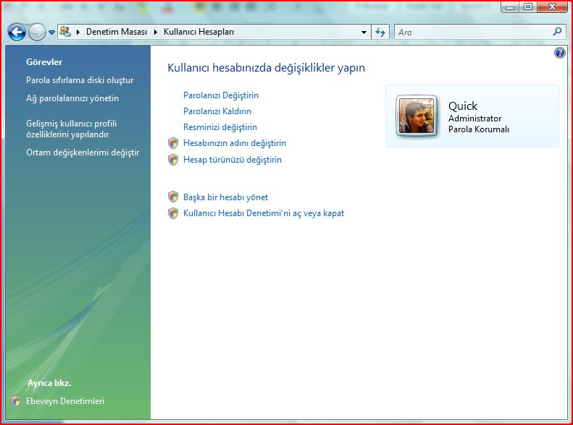

Uncheck the only check box in the opening window and restart your computer. If it is already unchecked, continue with the installation of postgreSQL.

Now open the directory “Pseudosoft-2008 / Setup / PostgreSQL 8.3” and begin with installing vcredist_x86.exe. If you do not install this, postgreSQL will give you a fatal error stating database initialization problem. There is no adjustment during its installation, just install it before installing postgreSQL.

It is time to install postgreSQL now. The adjustments we provide below are very necessary for our project to work properly.

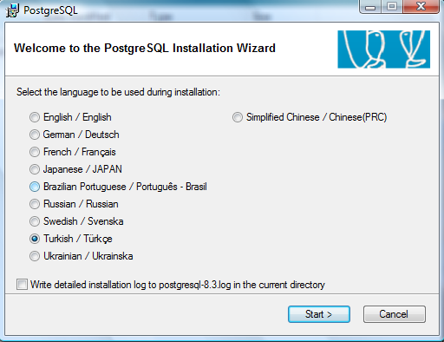

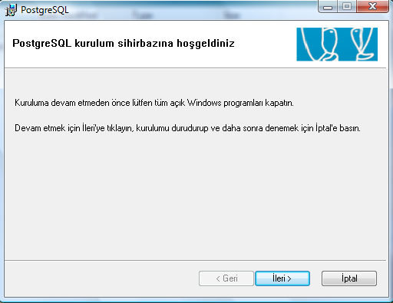

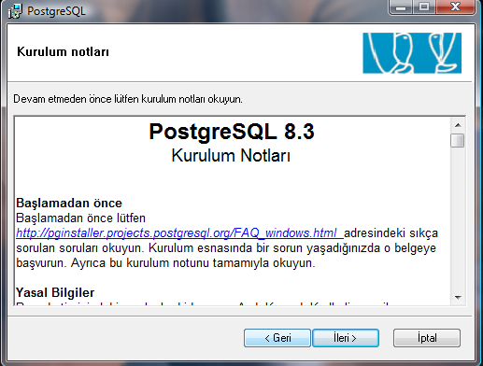

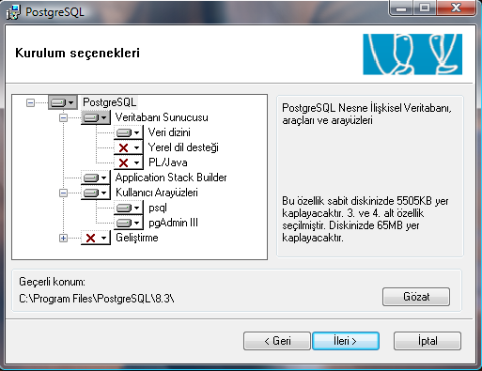

Give the password as: 12345

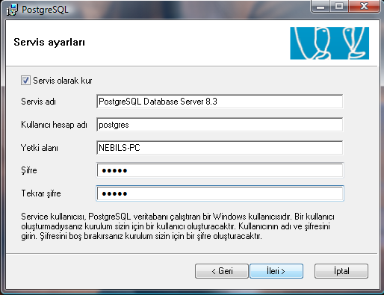

You must not change the port number. It should be 5432, so leave it as it is. Locale field is not important but take attention to the (Client) field, change that field to UTF8. Finally fill the password field with 12345 again and click next.

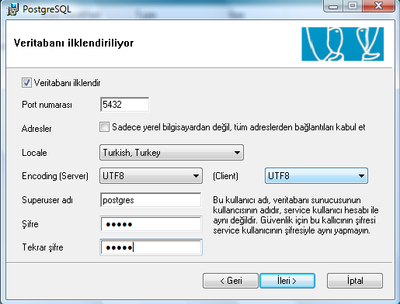

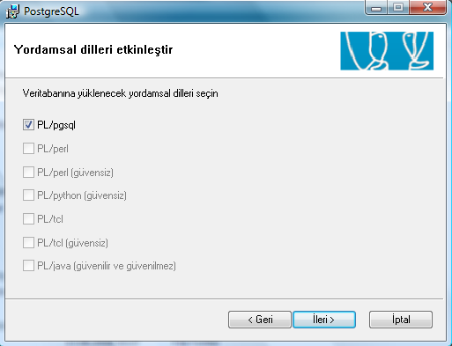

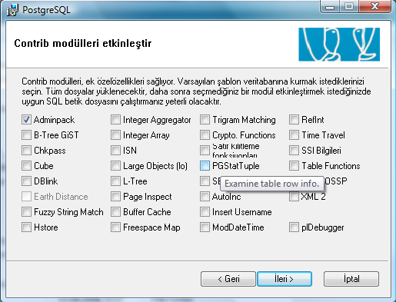

STEP 3 : Install Apache Tomcat 6.0.14.

While installing apache Tomcat, do not change the port it uses. Leave it as 8080.

STEP 4 : Deployment of .war files and providing .jar files as library

Open “webapps” under tomcat home directory, where you install tomcat. “D:\Program Files\Apache Software Foundation\Tomcat 6.0\webapps” for example.

Now if your tomcat is opened to service, close it by right clicking the icon in the task bar and choosing “Stop service” option.

Copy all the .war files under the “Pseudosoft-2008\Setup\war files” to the webapps under Tomcat.

Now open the lib directory under Tomcat (“D:\Program Files\Apache Software Foundation\Tomcat 6.0\lib” for example) and copy and replace all the .jar files from “Pseudosoft-2008\Setup\Tomcat lib” directory to “\Tomcat 6.0\lib”.

Execute your Tomcat web server (open Monitor Tomcat, then right click the Apache Tomcat icon in the task bar and choose “Start Service”) so that “.war” files we deployed before under “webapps” can be unpacked automatically. Then right click the Apache Tomcat icon in the task bar and choose “Stop service”.

“axis2” folder should have been created by Tomcat automatically under “Tomcat 6.0\webapps” after the last step. Copy and replace all of the .jar files from “\Pseudosoft-2008\Setup\axis2 lib” to “\Apache Software Foundation\Tomcat 6.0\webapps\axis2\WEB-INF\lib”.

STEP 5 : Deployment of Web services provided by the simulation of kariyer.net & yenibiris.com to our portal.
Open “\Pseudosoft-2008\Setup\Web Services”. Copy everything under that directory to “\Apache Software Foundation\Tomcat 6.0\webapps\axis2\WEB-INF\services”.

STEP 6 : Adjustment for JAX 2.1
There has to be some .jar files for applications using JAX-2.1 work properly under “\Tomcat\common\endorsed”. Therefore, copy the “common” folder under the “\Pseudosoft-2008\Setup\Tomcat Common” and paste it to your Tomcat home directory “\Tomcat 6.0”.
STEP 7 : Deploying the .jar files we developed providing the data access logic.
Open the “\Pseudosoft-2008\Setup\data-access jar files” and copy the three .jar files, namely:
- KariyerDatabaseUtilityHibernate.jar
- YenibirisDatabaseUtilityHibernate.jar
- PortalDatabaseUtilityHibernate.jar

Paste these three jar files into both :
  - “\Apache Software Foundation\Tomcat 6.0\lib”
  - “\Apache Software Foundation\Tomcat 6.0\webapps\axis2\WEB-INF\lib”

STEP 8 : Deploying the Web sites : The simulation of Bank, Kariyer.net, Yenibiris.com, and our portal Yenilink.
Open the “\Pseudosoft-2008\Setup\Web sites” directory and copy all four of the web sites to: “\Apache Software Foundation\Tomcat 6.0\webapps” and restart your Apache Tomcat.

Now our web sites are ready. You can access using the URLs given below.
- For Yenilink : http://localhost:8080/Yenilink
- For Yenilink admin panel : http://localhost:8080/Yenilink/adminPage
- For Kariyer simulation : http://localhost:8080/Kariyer
- For Yenibiris simulation : http://localhost:8080/Yenibiris
- For Bank : http://localhost:8080/Banka/

STEP 9 : Creating the databases for each system.
Open “PgAdmin III” and open the PostgreSQL Database Server 8.3 with the password 12345. Right click on the “Databases” and choose “New Database…” . Fill the Name field with “portaldb” and fill the owner field with “postgres”, do not make any other change and click on the “OK” button.
Follow the same procedure for the two simulation websites but this time give the database name “kariyerdb” and “yenibirisdb” respectively.

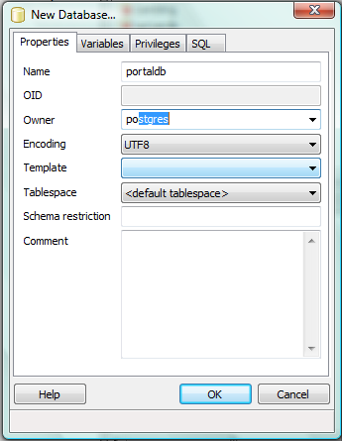
After creating databases, now it is time to create the necessary tables.
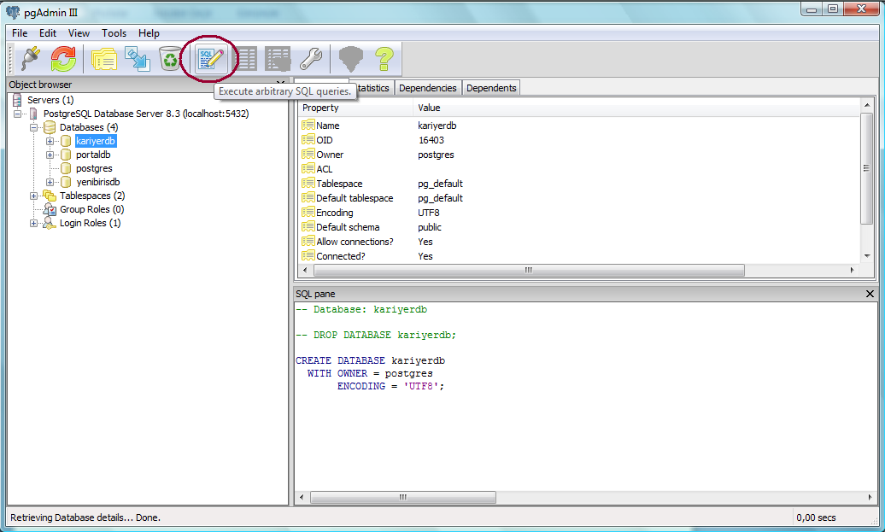
The text files under “\Pseudosoft-2008\Setup\Database scripts\Create DB&Tables\” are the “Create Table” scripts for creating the necessary tables of the corresponding databases.
Choose the “kariyerdb” and press the “SQL” icon as shown in the figure above. A query window will be open. Now open the “\Pseudosoft-2008\Setup\Database scripts\Create DB&Tables\kariyer.txt”. Copy all the script into the query window and press the execute button.

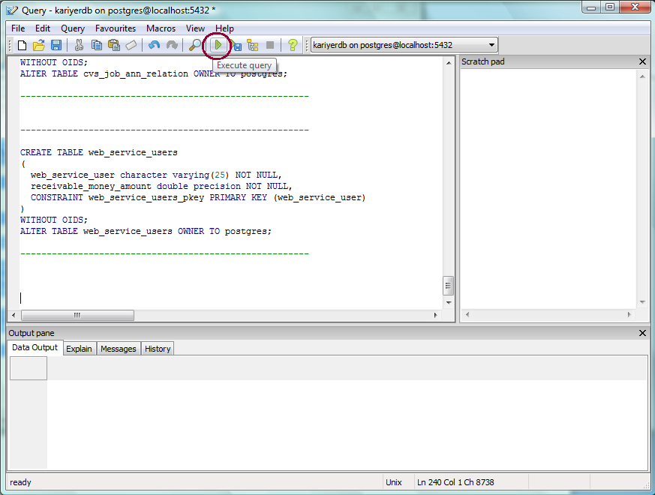

Do the same thing for the yenibirisdb and portaldb. First select the database, click on the SQL icon and then open the corresponding text file:
- “\Pseudosoft-2008\Setup\Database scripts\Create DB&Tables\yenibiris.txt” or
- “\Pseudosoft-2008\Setup\Database scripts\Create DB&Tables\yenilink.txt”
Copy the entire script in that file to query window and press execute button.

To make our system ready for usage, there is one final thing you should do. Click on the “portaldb”, right click the “jswss” (Job Seeking Web SiteS) and click “View data”.
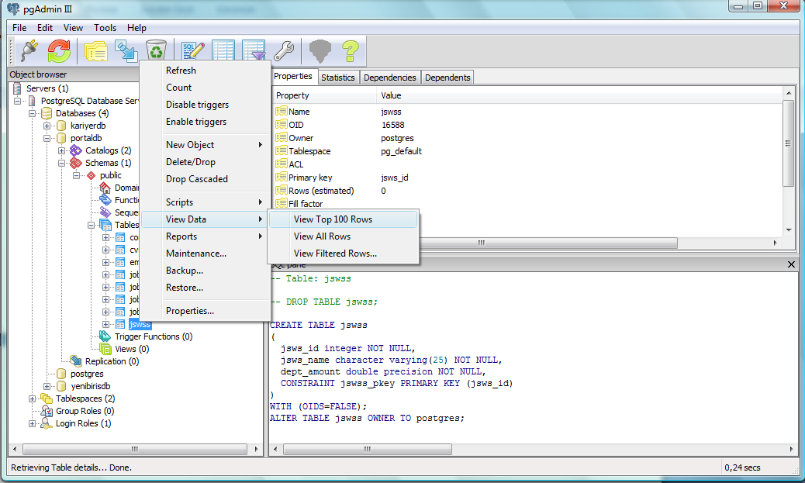
Add two rows namely:
- 1 Kariyer 0
- 2 Yenibiris 0

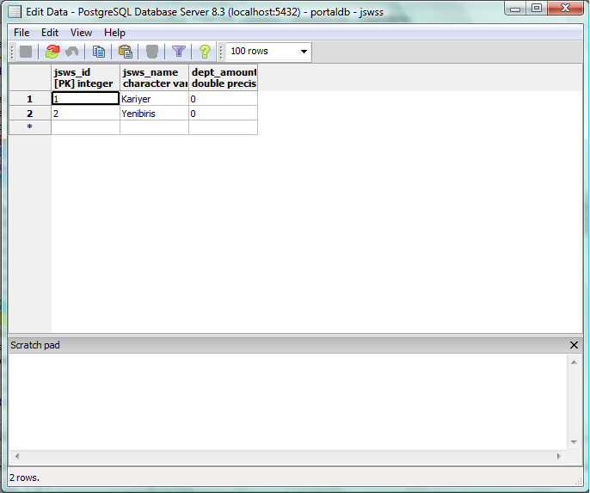
STEP 10: (OPTIONAL) Populating the database.

If you come thus far, our system should have become ready for usage. You can use the links we provided above to open the web applications. However, as you know the database is very empty now and it takes too much time to fill it. Therefore, we provide you backup of our tables of our databases which are filled with data.

The backup files of the tables are under the “C:\Users\Quick\Desktop\Pseudosoft-2008\Setup\Database scripts\Populated DB Backup” folder. Now, whenever you get bored with filling the fields you can use these backup files to store data to the databases. However, one thing you should take attention about using the backup files is, if you use these backup files after inserting some data, the data you inserted will be lost.

NOTICE! If you decide to use these backup files, we recommend you to backup all of the tables of all three databases. Otherwise, the system may and will encounter some inconsistencies.

There are three directories under “C:\Users\Quick\Desktop\Pseudosoft-2008\Setup\Database scripts\Populated DB Backup” namely: Yenilink, Kariyer, and Yenibiris.
Each directory includes one backup file for each tables that belongs to the database the name of the directory implies. You should restore each of those backup files one by one.
To backup a table of “Yenilink”, right click the “portaldb” in PgAdmin III and select “Restore”.

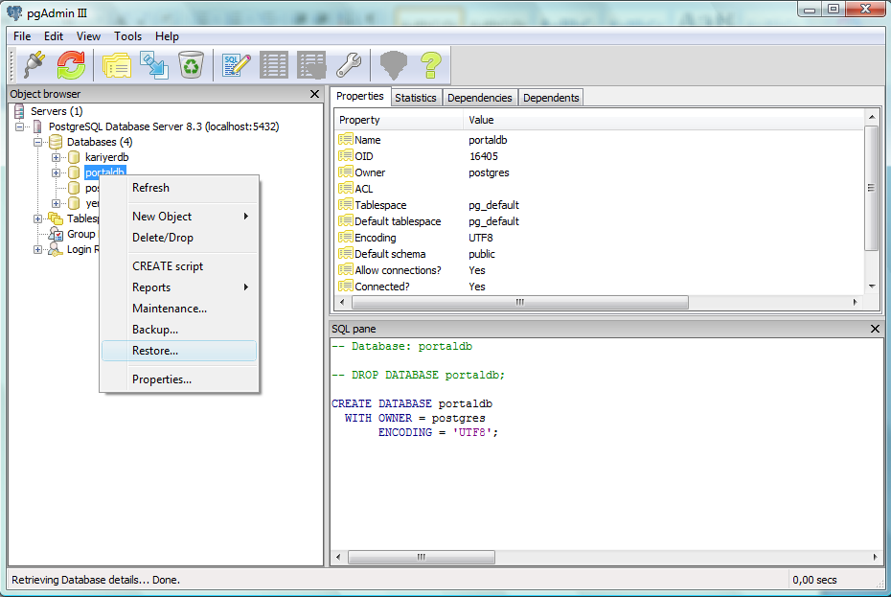
Browse the backup file you want to restore from the directory of backup files of Yenilink, and press OK button. There are 8 backup files under “\Pseudosoft-2008\Setup\Database scripts\Populated DB Backup\Portal” directory and you should restore them in the order of their names, so that no error occurs because of the foreign keys:

- p1.backup
- p2.backup
- p3.backup
- p4.backup
- p5.backup
- p6.backup
- p7.backup
- p8.backup

For simulation of the web sites, the procedure is the same. When you are restoring a backup file of “kariyer” simulation, right click the “kariyerdb” from PgAdmin III window and press the “Restore” option. Browse the backup file you want to restore from the directory of backup files of Kariyer, and press OK button. There are 5 backup files under “\Pseudosoft-2008\Setup\Database scripts\Populated DB Backup\Kariyer” directory and you should again restore them in the order of their names:

- k1.backup
- k2.backup
- k3.backup
- k4.backup
- k5.backup

Finally, for restoring the tables of the simulation of the “Yenibiris.com” right click the “yenibirisdb” form PgAdmin III window and press “Restore” option. Browse the backup file you want to restore from the directory of backup files of Yenibiris, and press OK button. There are 4 backup files under “\Pseudosoft-2008\Setup\Database scripts\Populated DB Backup\Yenibiris” directory and you should again restore them in the order of their names:

- y1.backup
- y2.backup
- y3.backup
- y4.backup

