CENG 491

ODAK YAZILIM

Weekly Progress Report

November 20, 2009

This week, we detailed the mobile application part of the project. The mobile application consists of three main modules, namely Communication with Device, Communication with Server, User Interface.

- Communication with Device: This module is responsible for opening the Bluetooth connection of the phone and searching for available special test device. After setting up the connection it will wait for an XML file consisting of test results, and then it will parse that file and display the results on the screen.
- Communication with Server: This module is responsible for sending the XML file to the THS Server.
- User Interface: This module displays the test results, sets up and cancels alarm and required other functionalities.

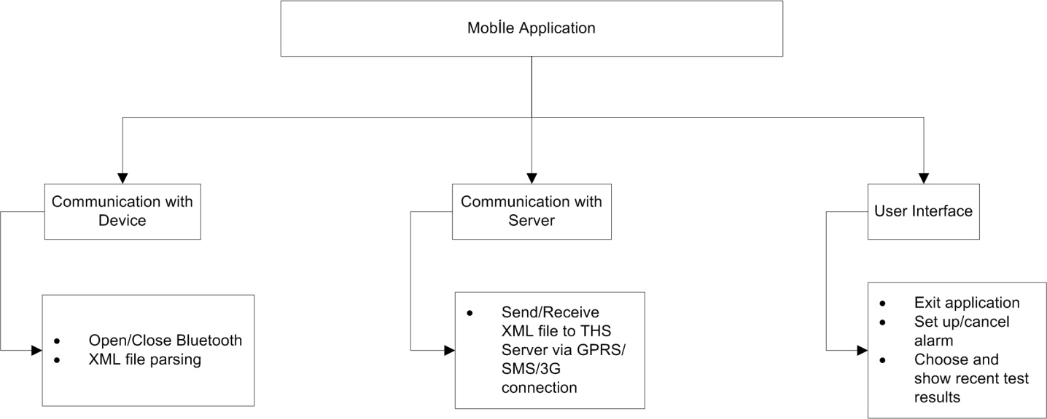

In addition, we started to learn how to develop a mobile application.

Birkan PALA
Faruk YILMAZ
Abuzer Miraç ÖZCAN

