A Product of Pseudosoft | Pseudosoft

PSEUDOSOFT | yenılınk portal user guide

INDEX
PREFACE 3
HOME PAGE 4
“BİREYSEL KULLANICI” PAGE: 5
“YENİ ÜYELİK OLUŞTURMA” PAGE FOR PERSONAL USERS 6
“KAYITLI KULLANICI” PAGE 7
“ŞİRKETLER” PAGE: 15
“YENİ ÜYELİK OLUŞTURMA” PAGE FOR COMPANIES 16
“KAYITLI ŞİRKET” PAGE 18
“İLAN ARAMA” PAGE 24
“TÜRKİYE İŞ KURUMU” PAGE: 28
SIMULATION OF CAREER WEB SITES ( kariyer & yenibiris) and the usage of Web Services. 30
BANK PAGE 33
ADMIN PAGE of YENİLİNK 34
CONTACT INFORMATION 36

PREFACE

Dear Users;
Welcome to our portal, Yenilink. Yenilink is a fascinating job seeking portal. In fact, it is not just an ordinary job seeking web page. It is also a bridge between different job seeking web sites. By the great advantages it provides, you don’t have to look for jobs from different job seeking web sites any more. You also don’t have to fill similar membership forms or CV creation forms. Digging job seeking web sites for different job announcements will be history for you by this system.
If you are a company, we also provide you nice features which will ease your job. After this you don’t have to create your job announcements in different job seeking web sites one by one. Our portal gives you job announcement creation service from one point. You can also create your company membership and you will directly be a member of our partner job seeking web sites. It will be a great opportunity to use our portal for companies because they will be able to know what is happening in different areas of work.
We also provide services for firms like İşkur. Their need for statistics about the current job, employee and sector status will be provided by these services. This will be a great opportunity for İşkur since they will have more information about the current situation and they will take their decisions accordingly.
After all, Yenilink is a legendary system for personal users, companies and İşkur. It is a real time saver. In this documentation about our project, you will find detailed user guide for all the functionalities of our system. We tried to support the documentation with snapshots of the system. We think it has been an easy and fun to read user guide. We are sure that you will not need to read it in order to use our system. Because our user interface is really simple and when you see it, you will not have any problems on understanding how to use the system. So this manual is a “just in case…”. We hope you will enjoy our system and this documentation.

PSEUDOSOFT

HOME PAGE

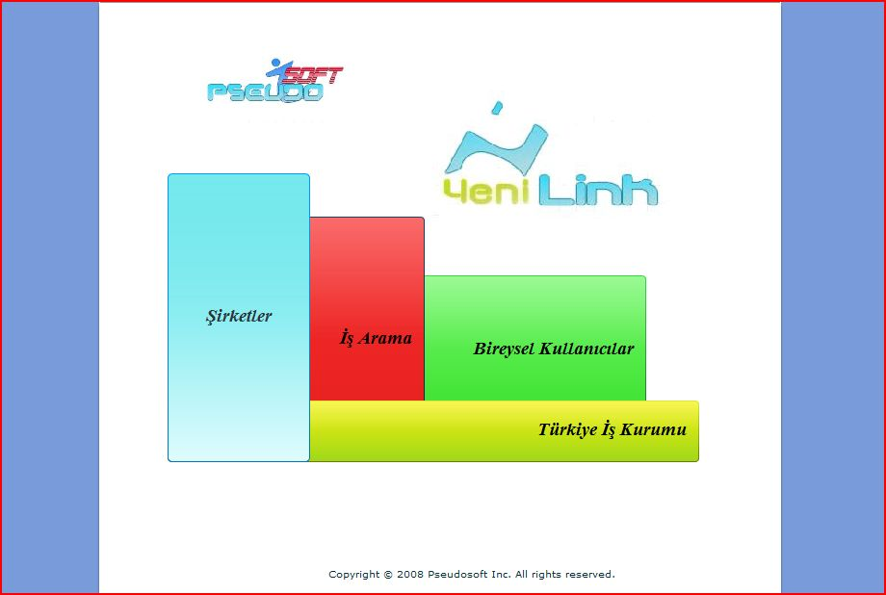

You can see the home page that will welcome you when you enter to our portal. Here there are some colorful links to different parts of our portal. You can basically click on the link and continue with the requested part of the portal. We want to shortly summarize what the links contain:
- “Bireysel Kullanıcılar” : This web page contains the personal user type services. You can create new user membership, see and update your account details, create CV’s and delete your membership from this link.
- “Şirketler” : This web page contains the company user type services. You can create new company memberships, create new job announcements, see and update previous announcements, see who has applied for the created announcements, update membership information and delete membership.
- “İş Arama” : You can search for job announcements with different criteria’s from this link. You can see the details of the job announcements found and even apply to them. You can use this service either as a logged in user or just an anonymous user.
- “Türkiye İş Kurumu” : With the special user name and password, İşkur will be able to see the matches and current situations of the sectors from this link.

Now we will give the details of the pages linked by these buttons.

“BİREYSEL KULLANICI” PAGE:

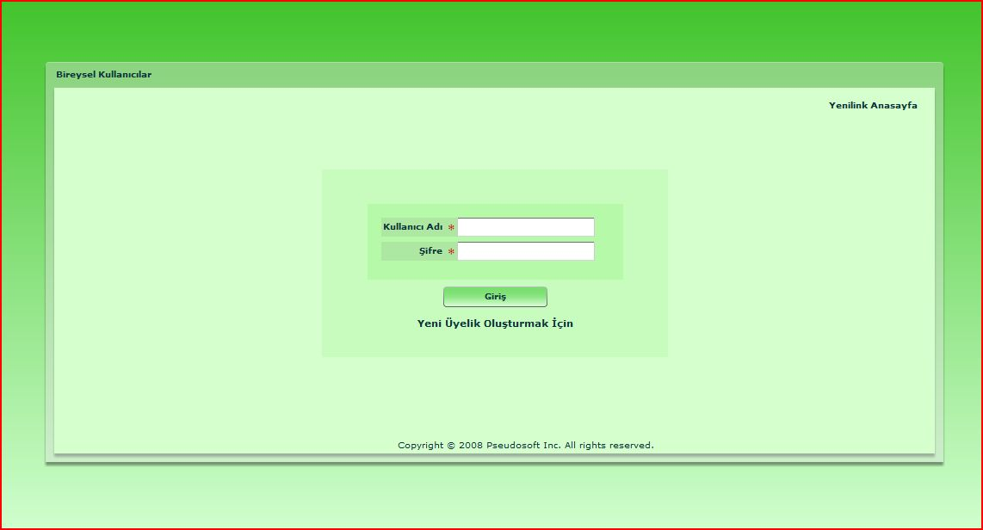

When you continue with the “Bireysel Kullanıcı” link, the above login page welcomes you. In this page, you can log in with your username and password, and continue with the registered user page. If you enter your password wrong, you will be alerted by “Şifrenizi Yanlış Girdiniz.” message. In this situation, retype your password. If an alert saying “Bu kullanıcı sisteme kayıtlı değildir.”, this means you have entered your username wrong or you are not a registered user since there is no user with the specified name in the system. Please check your username and retype again if necessary.
This page also contains links to the “Yenilink Anasayfa” which returns to the home page we have described above and “Yeni Üyelik Oluşturmak İçin” for creating a new personal membership. Now let’s go on with the contents of these pages.

“YENİ ÜYELİK OLUŞTURMA” PAGE FOR PERSONAL USERS

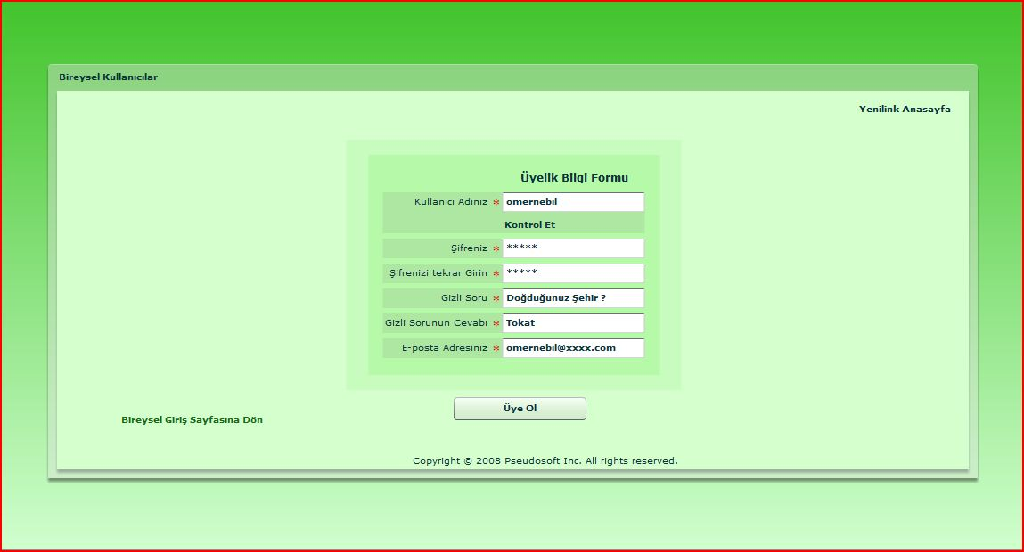
In order to create a new personal membership, you can use our “Yeni Üyelik Oluşturma” page. In this page, you will come across with a small form requiring your username, password, secret question, secret question answer and email. The steps for using this page are:
- You can choose yourself a username with 30 characters at most. You can check if the username you have chosen is in use by “Kontrol Et” button below the username field. If it says “Bu Kullanıcı İsmi Uygundur”, you can click Ok button and continue filling your form. Else you should choose another username and check again.
- In order to check consistencies there will be a check control in the password fields. Type the same password you choose to “Şifreniz” and “Şifrenizi tekrar girin” fields. If there is an inconsistency in these fields you will see “Girdiğiniz şifreler uyuşmamaktadır” alert. In this case, rewrite the passwords you choose to these fields again.
- After you completely fill all the fields, you can create you membership by simply clicking “Üye Ol” button. This action will create your accounts in our portal and in the job seeking web sites we are in collaboration with. You can cancel the creation process by simply clicking one of the links “Yenilink Anasayfa” or “Bireysel Giriş Sayfasına Dön”.
- When your account is created, you will be alerted about the acceptance of your membership and redirected to “Bireysel Giriş” page.

“KAYITLI KULLANICI” PAGE

This page contains three tabs consisting of “Özgeçmişlerim”, “Üyelik Bilgilerim” and “Yeni CV Oluştur”. We will go into the details of them later but now we want to say the common features which can be reached from all tabs.
- “Üyelik Kaldır” link: This link deletes your membership from our portal and the other job seeking web sites you have account in. When you click on this button, we ask for ideas about our portal and want your approval on deleting the membership with a pop-up windows as follows:
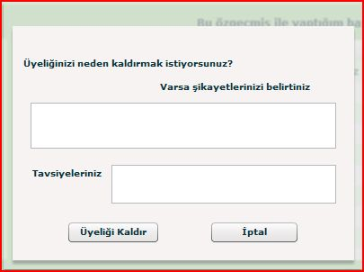

You don’t have to answer the questions but it would be great for us to develop our portal for later use. When you approve that you want to close your account, you will be redirected to the HOME PAGE.
- “Sistemden Çık” link: This link will sign you out after taking your approval on your decision. If you approve that you want to sign out, you will be directed to the HOME PAGE. Since you have signed out, you will need to log in again in order to come back to this page.
- “Yenilink Anasayfa” link: This link will direct you to the HOME PAGE without signing out. This link is especially useful when you want to search a job announcement because the link to the job announcement search page is on the HOME PAGE. You can turn back to this page by clicking “Bireysel Kullanıcı” button from the HOME PAGE and you will directly be in this page back again.

Apart from these common links, we included personal operations in tabs. Now it is time for us to talk about the properties of these paths.

- “Özgeçmişlerim” Tab:
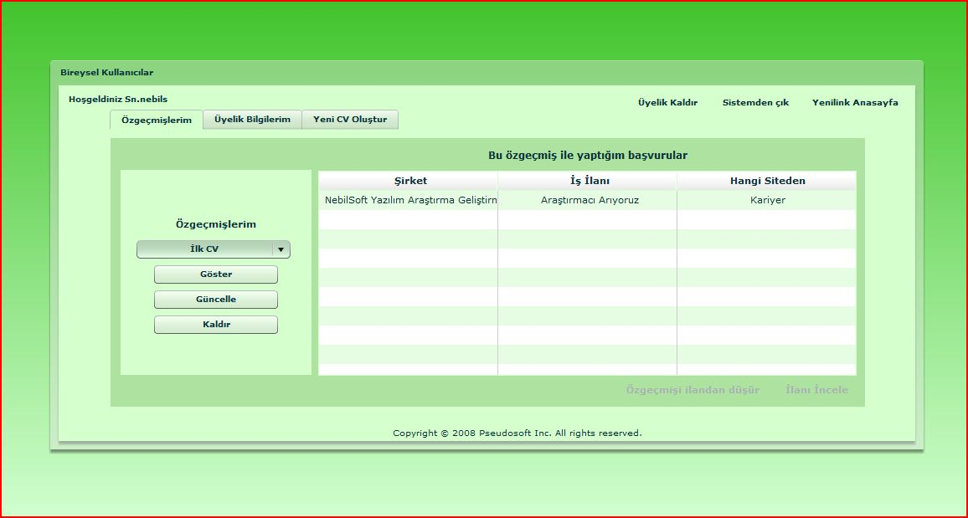
In this tab, you are provided information about the CV’s you have created and the applications you have made. On the table to the right of the page, you can see the applications you have made. The company information, the application name and the job seeking web site you have used to make the application is listed in this table. There are also two functionalities related with the rows of this table. One is dropping the application you have made and the other is for see the announcement in detail. When you select a row the below links to these functionalities will be activated. By clicking on “İlanı İncele”, you can see the details of an announcement with a popup page as below:
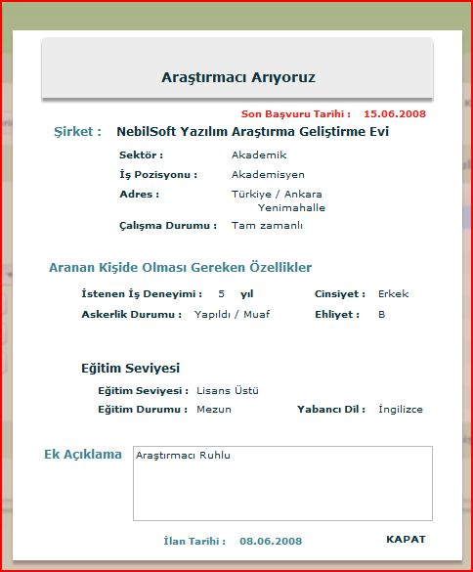

From this popup you can recall the details of the job announcement you applied before. So it is a good reminder. You can simply close the popup by clicking “Kapat” link located right below corner of the popup. If you think that you don’t want to continue your application process any more for an announcement, you can cancel your application by clicking “Özgeçmişi İlandan Düşür”. When you click this link, a popup will appear asking for your approval. If you approve that you want to cancel your application to the announcement, there will be no records of your interest on the announcement any more.
On the combo box of “Özgeçmişlerim” to the left of the page, you can see all the CV’s you have created by our portal. By “Göster” button, you can see the details of the CV you have created in an unchangeable format within 3 pages. It is really simple to see the details by this method so we didn’t need to describe it in detail. You can click “Kapat” button when you no longer want to see the details of your CV. By “Güncelle” button, you can update your information of a CV created. Now we are giving the details of this function:
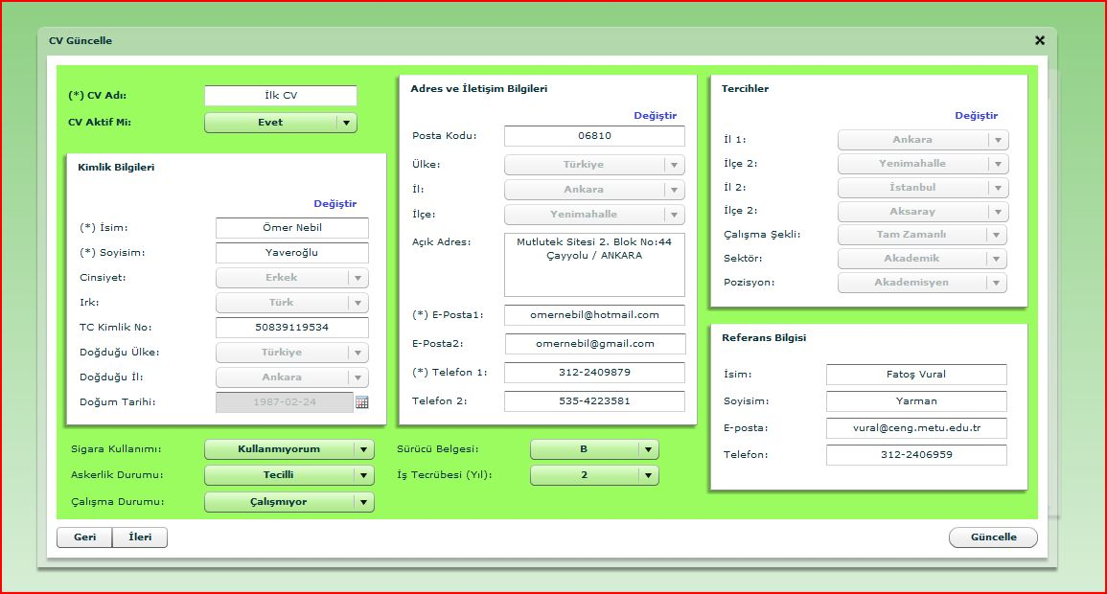

IMPORTANT: Now, take attention to the "Kimlik Bilgileri", "Adres ve İletişim Bilgileri", and "Tercihler" sections in the "CV Güncelle" component. The fields in those panels are disabled to be changed. This is not an error, or bug. It is instead a patch to a bug. It is not necessary to mention about the details, but when a user wants to change any field in any of those panels, he/she has to press to "Değiştir" link button at the top of the corresponding panel. Then the fields under that panel will be enabled to be changed. That bug was simple to be handled but due to the time lack we prefer to modify that part of the code, instead of changing it completely.
Other then this important point, you can feel free to change each field as you want and click “Güncelle” button to save the changes and close the tab. There are two pages displaying the CV. You can switch between these two pages by “Geri” and “İleri” buttons.
As a final operation on CV’s, you can delete a CV you have created by “Kaldır” button. When you click this button, you will come across with an approval page as usual. If you click OK, your CV becomes history.
- “Üyelik Bilgilerim” Tab:
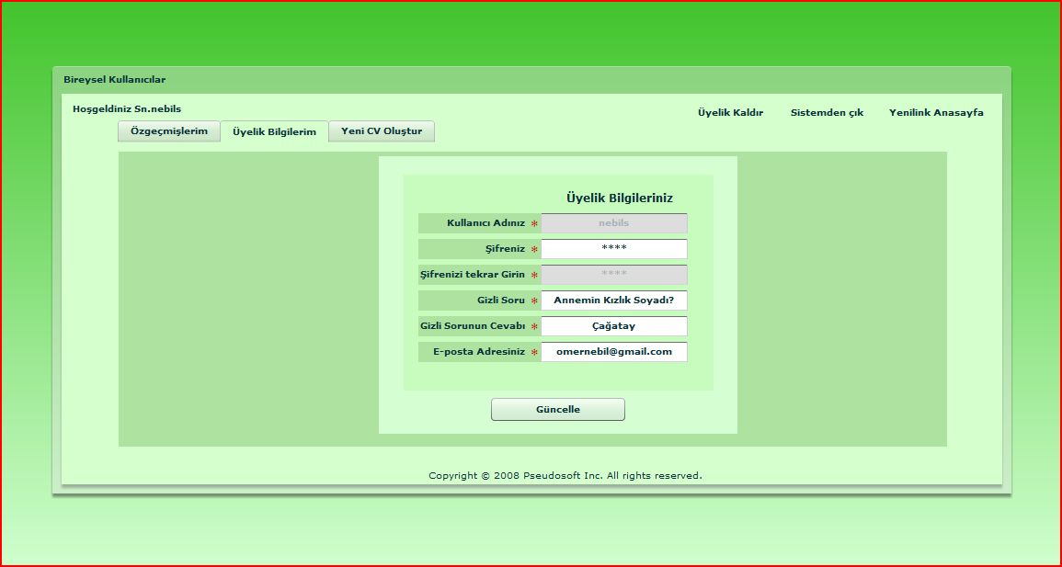
In this tab, you will be able to see the membership details you have given during your membership creation. You can also update these by changing the editable areas. One important point to note is that, when you change “Şifreniz” field, “Şifrenizi tekrar Girin” field will be enabled and you have to type your password again for consistency checking. When you click “Güncelle”, your new data will be saved.
- “Yeni CV Oluştur” Tab:

This tab consists of seven subpages named “Temel Bilgiler”, “Eğitim Bilgileri”, “İletişim Bilgileri”, “Yabancı Dil ve Bilgisayar Bilgisi”, “Referans Bilgileri”, “Çalışma Bilgileri” and “Ek Bilgiler ve Onay”. As a general rule, in order to create your CV, don’t leave any fields marked with “*” empty. Now let’s continue with the details of these sub pages.
  - Temel Bilgiler: In this part of the CV, we require some personal information about you just like your name, surname, place and date of birth, gender, etc. You must fill all the fields in this subpage for your CV to be accepted.

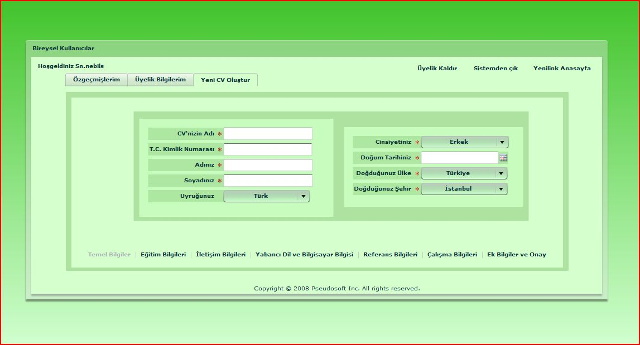

  - Eğitim Bilgileri: In this subpage, we will require your information about education. In the main page of this subpage, you will select the education level you have and current status about education. Depending on your choice, the link above will be activated. For example; if you choose “Üniversite” as your education level, “Lise Bilgileri” and “Lisans Bilgileri” links will be activated and you will be able to enter your related information by clicking on these links.

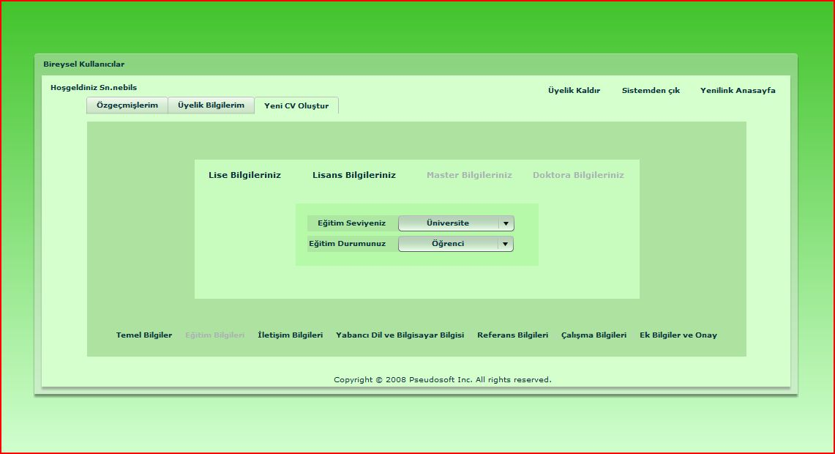

  - İletişim Bilgileri: In this subpage, you will be required some communication information like your address, telephone, email. The mandatory fields in this page are “Ülke” , “İl”, “Eposta” and “Telefon”. Basically fill the fields required and you prefer, and continue with the next subpage.
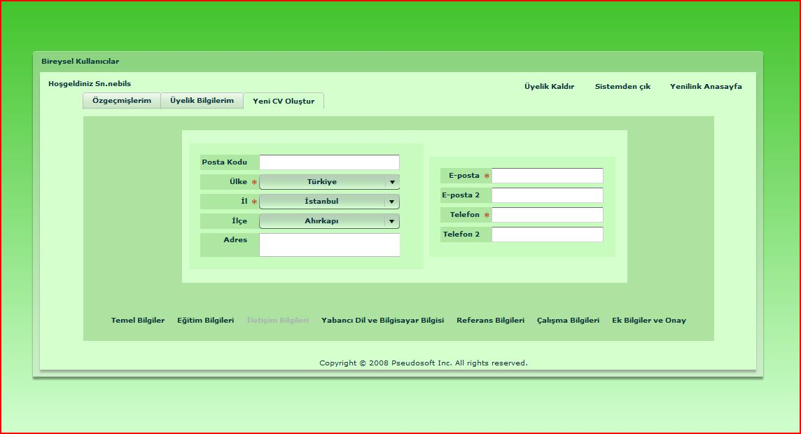

  - Yabancı Dil Bilgileri: In this page, you will be asked for your computer and foreign language knowledge. You can select one of the languages and rank your level on reading, listening and writing from 1 to 5. (1 means worst, 5 means best) You can also select five of the computer related tools that you know. All the fields in this page are optional.

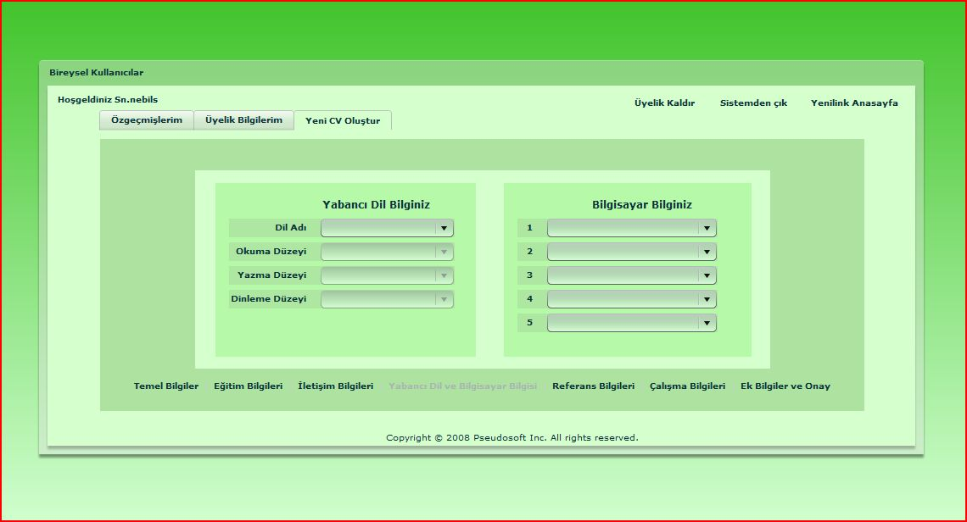

  - Referans Bilgileri: You can enter one of your references name, surname, telephone and email information in this page. All the fields are optional.

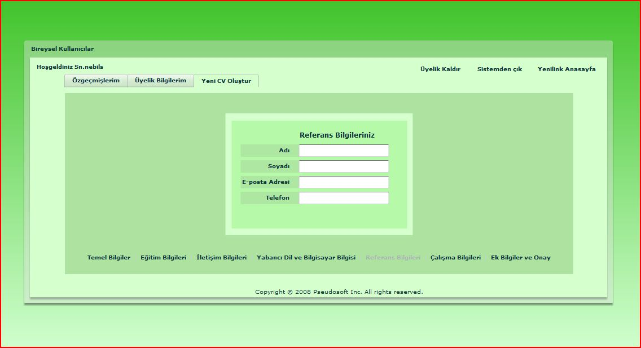

  - Çalışma Bilgileri: In this subpage, you will enter working status and preferences. On the left side of the page, you are required for your previous working experience in years and current working status. On the right side of the page, you can include information for your working preferences such as sector, position, country and city. All fields are optional but we guarantee that it will help on companies to decide about you a lot.

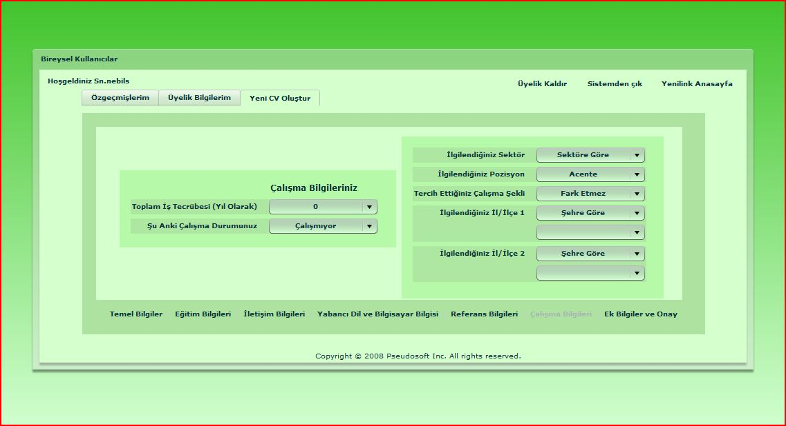

  - Ek Bilgiler ve Onay: In this final subpage of CV creation, you are able to enter some information like smoking habit, driving license, military obligations and any other thing you want to add like personality information. All these fields are again optional. After making sure that you didn’t leave any mandatory fields empty and all of your information is correct; click on the “CV Oluştur” button and you have a new CV. We hope, it will help you find a new job.

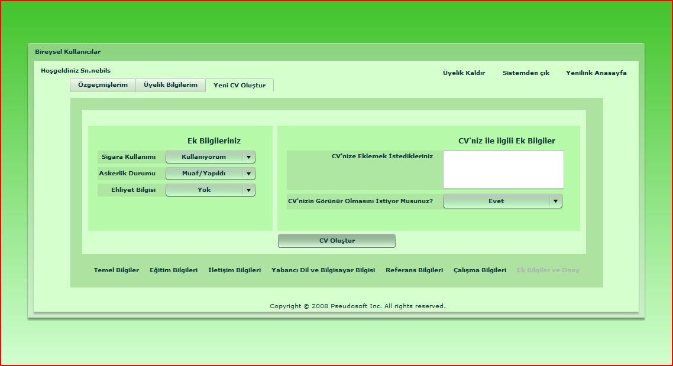

This is all about “BİREYSEL KULLANICI” page. We hope this documentation will satisfy you about everything you need in order to use our portal as a personal user. In order to get information about how to search a job, see the chapter about “İLAN ARAMA” page. We welcome your questions by email from the addresses you will be able to find at the end of this document.

“ŞİRKETLER” PAGE:

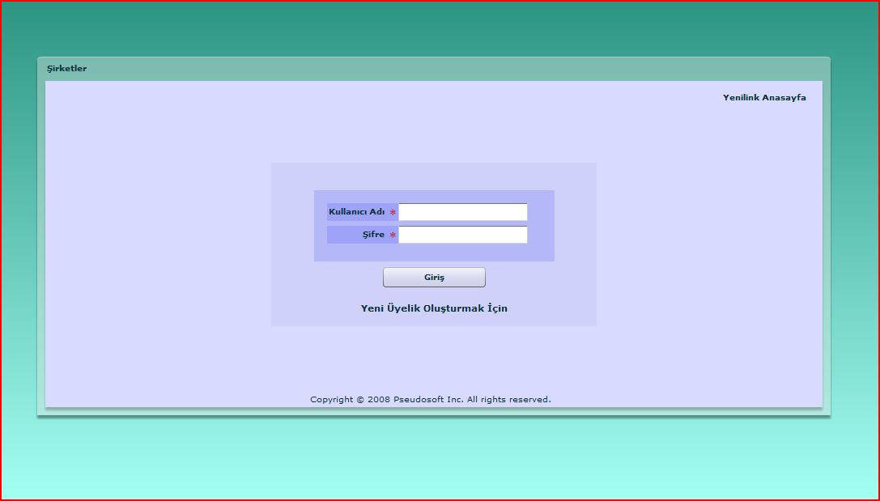

When you continue with the “Şirketler” link, the above login page welcomes you. In this page, you can log in with your username and password, and continue with the registered company user page. If you enter your password wrong, you will be alerted by “Şifrenizi Yanlış Girdiniz.” message. In this situation, retype your password. If an alert saying “Bu kullanıcı sisteme kayıtlı değildir.”, this means you have entered your company username wrong or you are not a registered company user since there is no company user with the specified name in the system. Please check your company username and retype again if necessary.
This page also contains links to the “Yenilink Anasayfa” which returns to the home page we have described above and “Yeni Üyelik Oluşturmak İçin” for creating a new company membership. Now let’s go on with the contents of these pages.

“YENİ ÜYELİK OLUŞTURMA” PAGE FOR COMPANIES

Creating a company membership is more complicated than creating a personal membership because it requires more information. When you click on the “Yeni Üyelik Oluşturma” link, you will come across with the following web page:
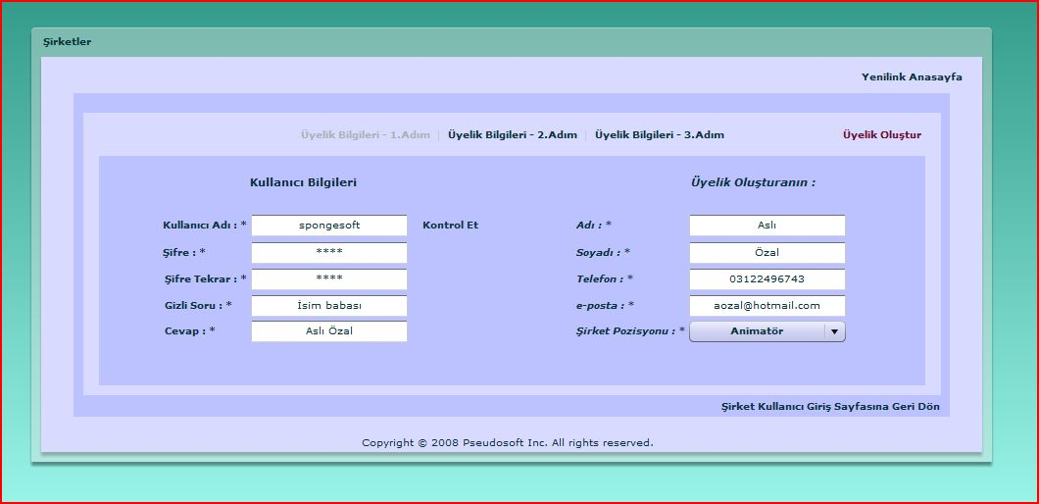

In this page you have the opportunity to cancel your membership creation and return back to the Yenilink Homepage by following the link “Yenilink Anasayfa”. You can also turn back to the “Şirketler” page by clicking the “Şirketler Kullanıcı Giriş Sayfasına Geri Dön” link. This will direct your to the previous login page that you have seen one step before. We needed to divide the forms of company membership creation into three subpages because there were too many information to require from you. You can see the links to these subpages above the page with “Üyelik Bilgileri – X. adım”. Now we will mention some details about these 3 subpages.
- “Üyelik Bilgileri – 1. Adım” : In this step of membership creation you are required to write the accounts details that you want to create and the information about the employee that is responsible for using our portal in the company. All the fields are mandatory. When you are selecting a username for the company, you can check the usernames availability by “Kontrol Et” link near the Kullanıcı Adı” field. If a popup appears saying “Bu kullanıcı ismi uygundur.”, this means that there are no other users in our portal with that name and that username is safe to use. After filling all the fields you can continue with the second page of membership creation.

- “Üyelik Bilgileri – 2. Adım” :

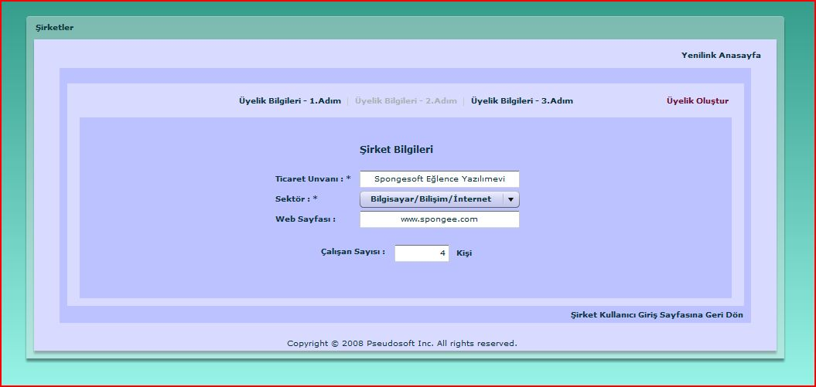

In the second, step of membership creation, you are required to enter your companies trading name, sector, employee number and web page. Only the trading name and sector fields are mandatory in this page. You can continue with the third step of membership creation after you at least enter the required information to the related fields.

- “Üyelik Bilgileri – 3. Adım” :
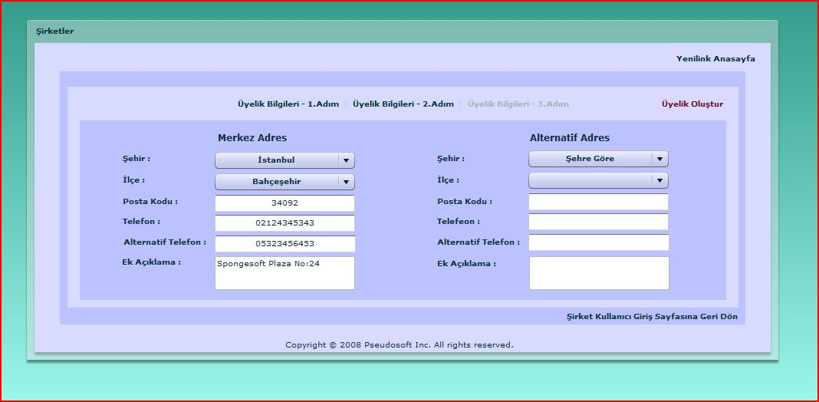
In this field, you are required to enter your company’s address information. 2 addresses are allowed but giving address information is not a must. Keep in mind that for your companies prestige, giving address information is really a big plus.

After you complete filling these forms (at least the mandatory fields), you can save your membership by clicking the “Üyelik oluştur” link. If any information you have given don’t contain any format errors or there are no missing information, your account will be created on our portal and the job seeking web sites we are in collaboration with. You will be alerted on the error if there is anything wrong with the thing you have written. You will be redirected to login page when your membership is created successfully.

“KAYITLI ŞİRKET” PAGE
When a company signs in using the login page, it will be directed to this page. The first screen that will be displayed is as below:
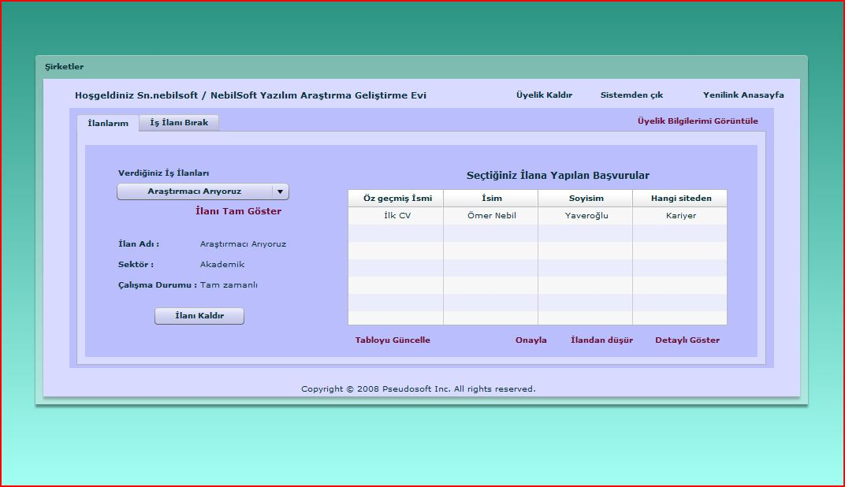
As you can see from the above screen shot, there are two tabs we provide for company users. In the first “İlanlarım” tab, the announcements and the applications made for the given announcements are shown. The other “İş İlanı Bırak” tab is used for creating new job announcements. We will go into the details of these tabs later but now we want to mention the common links that are shared in all these tabs.
- “Üyelik Kaldır” link: This link can be used whenever you need to delete your membership from our portal. We are sure that you will not want to use this property. But in case that you want to use, click on this link. A popup will appear as below.
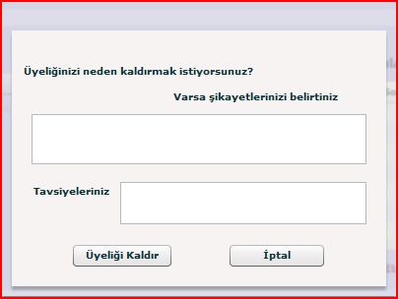
You can give your ideas about out portal in the text fields given. You can then select “Üyeliği Kaldır” for canceling your account (Attention: Clicking on this button means you approve to cancel your account. Your account will immediately be deleted when you click on it. So we recommend you to be careful on using this button). You can also change your mind and stop canceling by clicking on “İptal” button.
- “Sistemden Çık” link: This link logs you out from the system. Whenever you click on this link, an approval popup will be displayed. Using this popup you can logout by clicking “Evet” button or close the popup by clicking “İptal”. You will be directed to “HOME PAGE” of our portal when you log out.
- “Yenilink Anasayfa” link: This link allows you to turn back to “HOME PAGE” of Yenilink without logging out. This function is especially useful when you want to search for job announcements that are given to the portal and understand what is happening in business sectors. By clicking “Şirketler” link in the home page you can turn back to “KAYITLI ŞİRKET” page with your account.
- “Üyelik Bilgilerimi Görüntüle” link: Using this link you can see the details of your membership account. We show the information you have given in the account creation. In order to show the all details, we needed to divide the information into two subpages in the component. In the first one, we show the information about your company and membership. In the second subpage, we show your address information. You can change any field allowed but be careful on not leaving any mandatory fields marked by “*” empty. After you make the necessary changes, you can update your information by clicking “Kaydet” button at the bottom of the page. You can also just have a look at your information and close the popup by just clicking “Kapat”. You can see these two pages below:
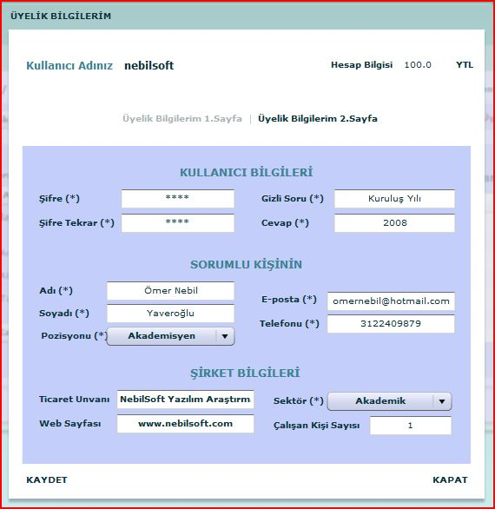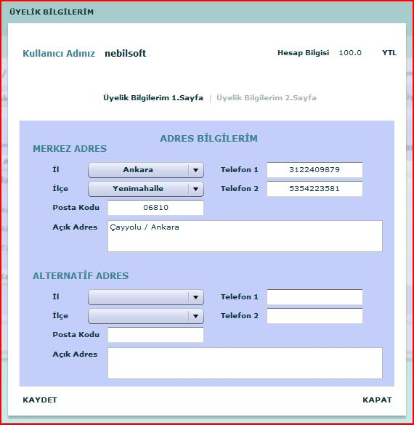
Apart from these general functionalities, as we mentioned earlier in this text, we have tabs that gives you the real functionalities that you can do with your account. Now let’s see these tabs in detail.
- “İlanlarım” Tab:

With this tab, we give you the ability to process the announcements you have created before. On the left side of the page, you can see the announcements you have created from the combo box. By selecting an application, you can see the details of the announcement, delete the announcement and see who has applied for the announcement you have selected from the table to the right of the page. You can also process the applications done to the announcement. Now let’s see the usage of these functionalities in detail.
  - “İlanı Tam Göster” link:
When you select an announcement from the combo box of announcements, you can see the details of the selected announcement by clicking on this link. A popup will appear showing the details of the job announcement as below:
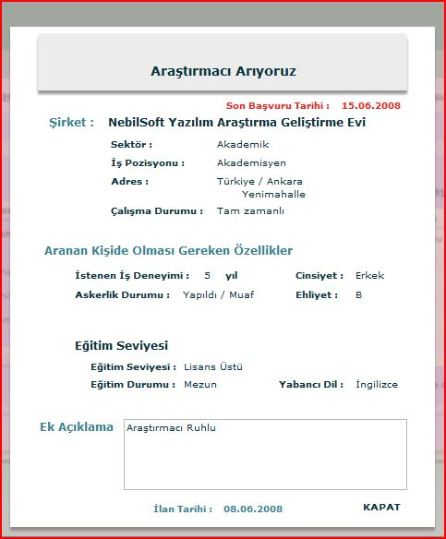
You can see the details of the announcement for recall purposes in this way. All you have to do in order to turn back to the previous page closing the popup is clicking on “KAPAT”.
  - “İlanı Kaldır” link:
Using this link you can delete a job announcement created before. After you select the announcement to remove, you can click on this link and then an approval page will appear. After approving that you want to delete that announcement, you announcement will be deleted and removed from our database.

  - Application related links:
After selecting an announcement, you can see the applications done for that announcement from the table you can see on the right side of the page. When you select an announcement, the table is automatically filled with the related applications. But during the time you work, new applications may have arrived. In order to update the list of applications you can use “Tabloyu Güncelle” link.
You can process the applications done by three choices ; “Onayla” meaning approve , “İlandan Düşür” meaning drop the announcement and, “Detay Gör” meaning see the details of the applicant. In order to use these you must select an application. Else you will be warned by “Öncelikle Bir Özgeçmiş Seçiniz”.

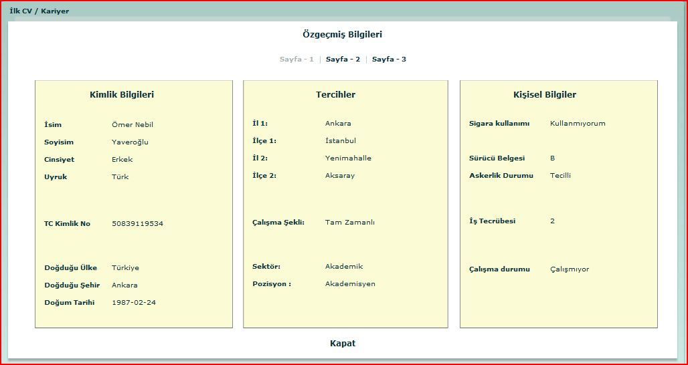

In three pages, you can see the details of the CV and when you are finished “Kapat” link will close the popup showing the CV. Then you can use “Onayla” for approval of this CV or “İlandan Düşür” for rejecting it. You should make your own communication with the client. This function is just for letting us know and clean the applications table. It will also be a great pleasure for us to hear from you because we update our statistics using that information.

- “İş İlanı Bırak” Tab:
You can create a job announcement using this tab. There are two subpages inside this tab. You enter the announcement related information using these two subpages.
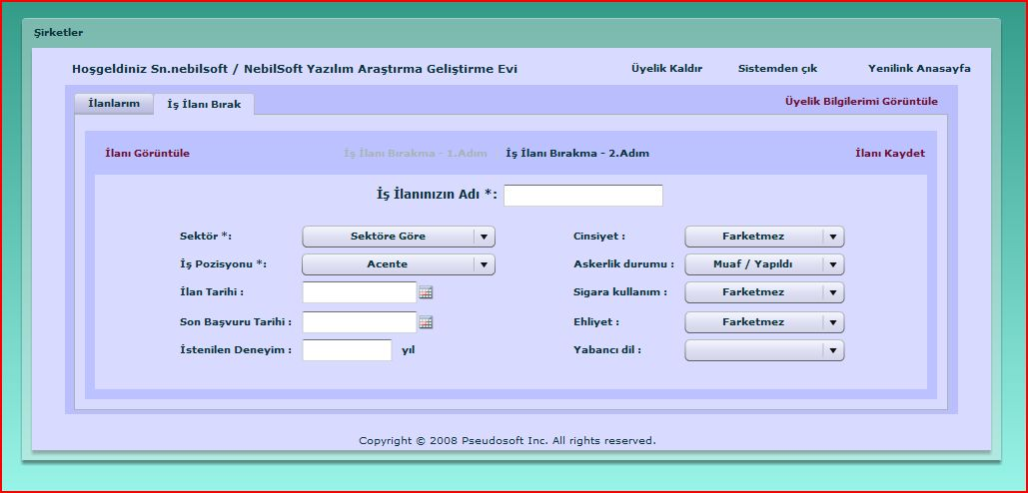
In the first page, you fill the basic information about your requirements from the applicants. In this page the only mandatory fields are “İş İlanınızın Adı”, “Sektör” and “İş Pozisyonu”. You can give a date range on the announcement to be published by “İlan Tarihi” and “Son Başvuru Tarihi”. “İlan Tarihi” represents the start date of the announcement and the “Son Başvuru Tarihi” gives the final date for applying the announcement.
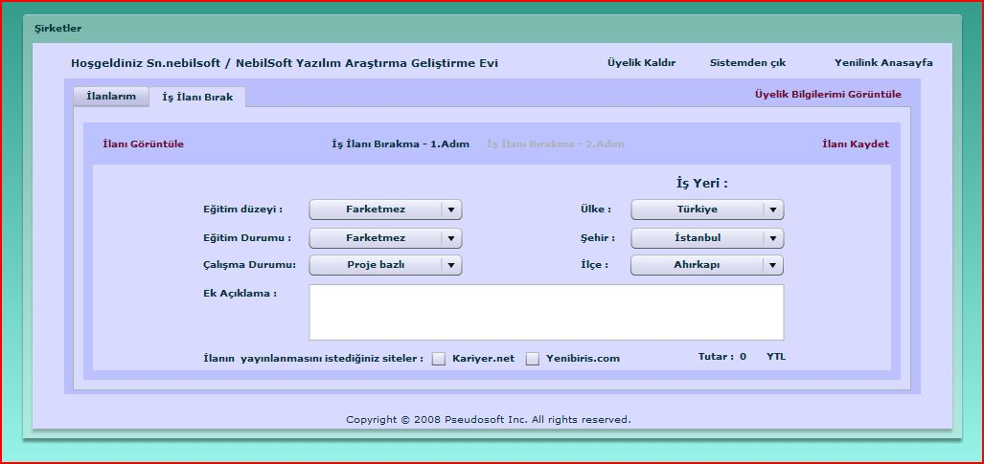
In the second page, you continue giving information about requirements and work place. Since publishing your announcements costs some money, you can click on the web pages that you want to announce this information by the check boxes near the job seeking web site names. The total cost will be automatically calculated at the right bottom corner of the page. You must have enough money in your account to pay. Else make some payment to us and you will be able to leave the announcement.
Before you leave the announcement, you can see how it looks like by clicking on the “İlanı Görüntüle” link at the top right corner of the page. It will create a popup as below and you will be able to see the announcement as a whole.
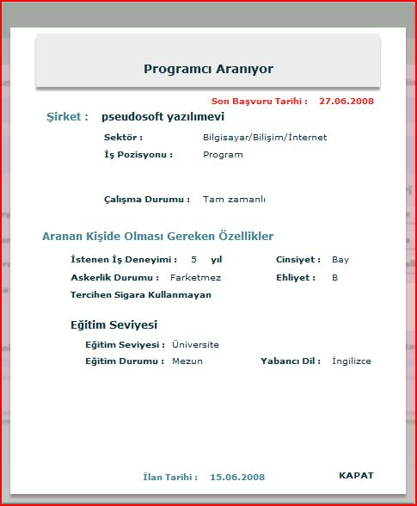
If you have sufficient money under your account and if you want to publish this announcement, you can save the announcement by “İlanı Kaydet” link. You announcement is created! We hope you will find some employee just as you want.

This is all about “ŞİRKETLER” page. We hope this documentation will satisfy you about everything you need in order to use our portal as a company user. In order to get information about how to search a job, see the chapter about “İLAN ARAMA” page. We welcome your questions by email from the addresses you will be able to find at the end of this document.

“İLAN ARAMA” PAGE
Yenilink provides many different job announcement searching mechanisms for even unregistered users. By the “İlan Arama” page, we have grouped all these mechanisms altogether.
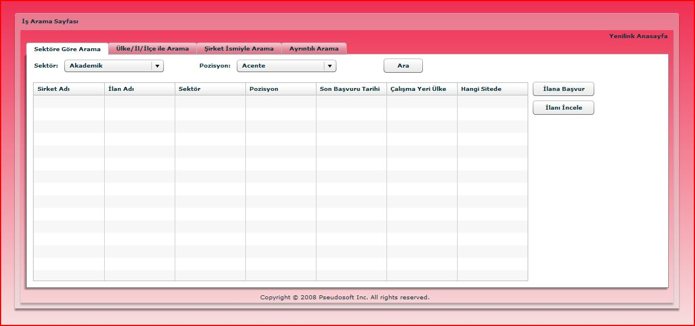

You can see the starting page of “İLAN ARAMA” page above. You can return back to the “HOME PAGE” anytime you want by clicking “Yenilink Anasayfa”. Also as you can see from this page we have four tabs; one for searching based on sectors are positions, one for searching based on country, city and town, one for searching based on company name and one for searching in detail. The common point in all these fields is that they all have the same mechanism for showing the results. When you make a search, you can see the query results in the table show in the middle of the page. From this page you can select an announcement and then look for details and even apply. When you select a job announcement and click “İlanı İncele” a popup showing the details will be shown as below:
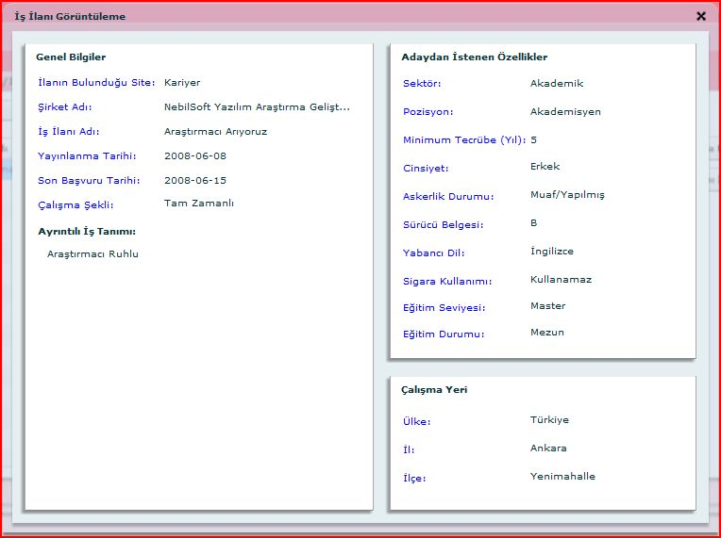
After looking at the announcement details in this way, you can close this popup by the “X” button at the top right corner of the popup.
If you think that this application is suitable for your needs you can apply the announcement you have selected by clicking “İlana Başvur”. If you are registered personal user and your account is open at that time, your will be required for a CV to apply. Else you will be required to open your account as a personal user. Then CV requirement popup will be shown including all the CV’s you have created under that account. An example CV selection popup will be as below.
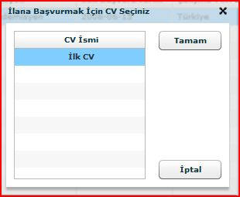
By selecting a CV and clicking “Tamam”, your application will be complete. You can cancel the application process by clicking “İptal”. This process is the same in all of the tabs. Now let’s see what kind of searches we can make by using our tabs.
  - “Sektöre Göre Arama” Tab: In this tab, you are required to insert sector and position information of the job you are looking for and your search will be done based on this basis. A sample search and result page of this type of search is as below:
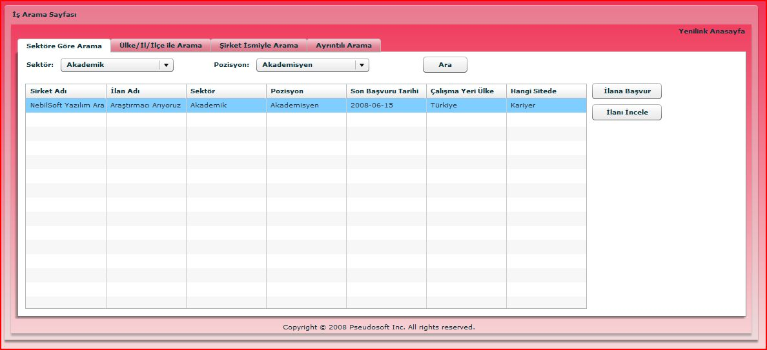

  - “Ülke/İl/İlçe ile Arama” Tab: In this tab, you are required to insert country, city and town information of the job you are looking for and your search will be done on this basis. A sample search and result page is as below.
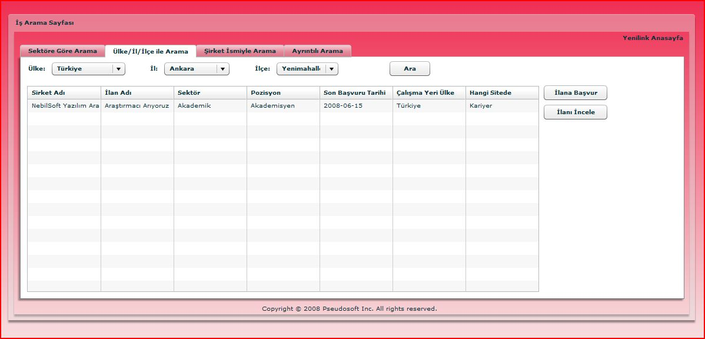

  - “Şirket İsmiyle Arama” Tab: In this tab, you are required to write the company name that you want to work in and your search will be done on this basis. A sample search and result page is as below.

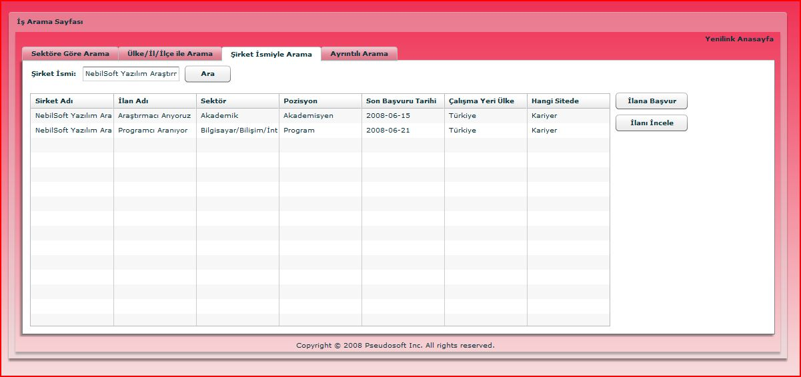

  - “Ayrıntılı Arama” Tab: In this tab, you are allowed to enter any type of information on the job announcement except the company name. A sample search page is shown below. Give as many criteria’s as you want and make a search. You can use search results just as defined above.
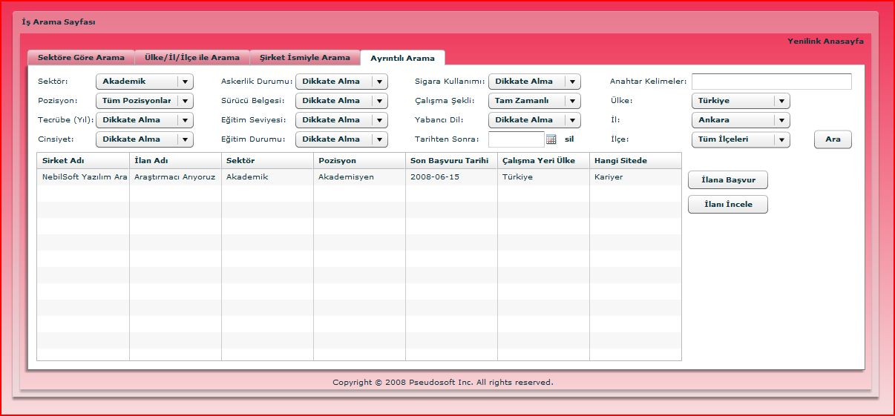

This is all about “İLAN ARAMA” page. We hope this documentation will satisfy you about everything you need in order to use our portal for searching a job announcement. We welcome your questions by email from the addresses you will be able to find at the end of this document. We hope it will help you find the job of your dreams.

“TÜRKİYE İŞ KURUMU” PAGE:
This page is designed for “Türkiye İş Kurumu” and the companies that pay to see the same statistics with İşkur. The homepage as below welcomes the users:

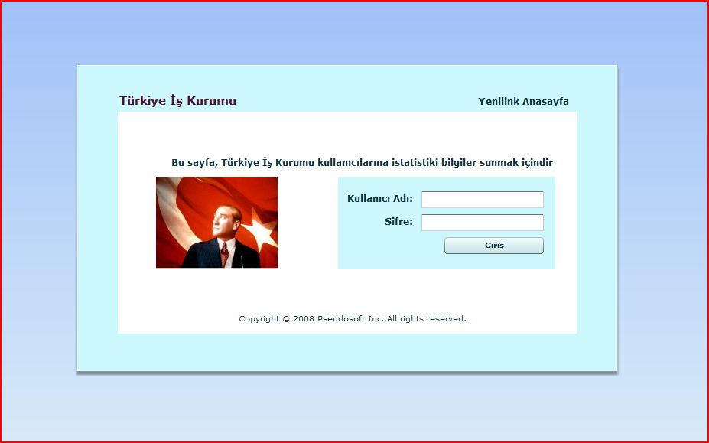
From this page, the users may return back to the home page our our portal, Yenilink. In order to login you should fill the “Kullanıcı Adı” and “Şifre” fields. We provide only one is-kur user whose username and password is “iskur”. After you login to iskur page, a query window will be opened.

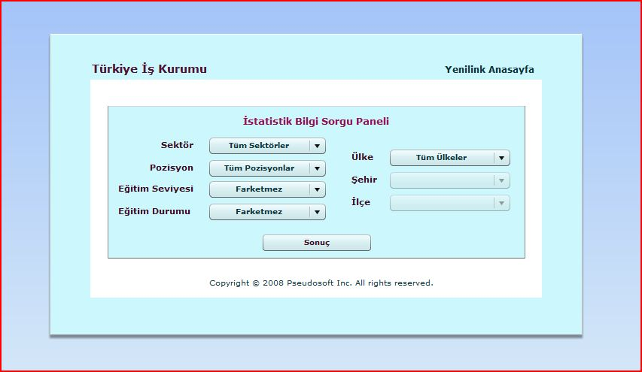
You can give any criterion you want from the combo boxes and when you press “Sonuç” button a result page including a graphic that represents the matches of last three months according the criterions you give. If you press “Sonuç” button before giving any criterion, the graphic will show you all matches of the last three months.
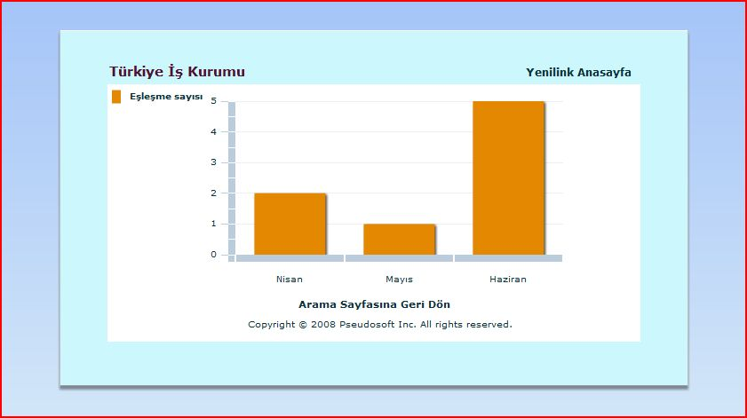

SIMULATION OF CAREER WEB SITES ( kariyer & yenibiris) and the usage of Web Services.

Beside Yenilink, we have simulated two career web sites namely kariyer.net and yenibiris.com.
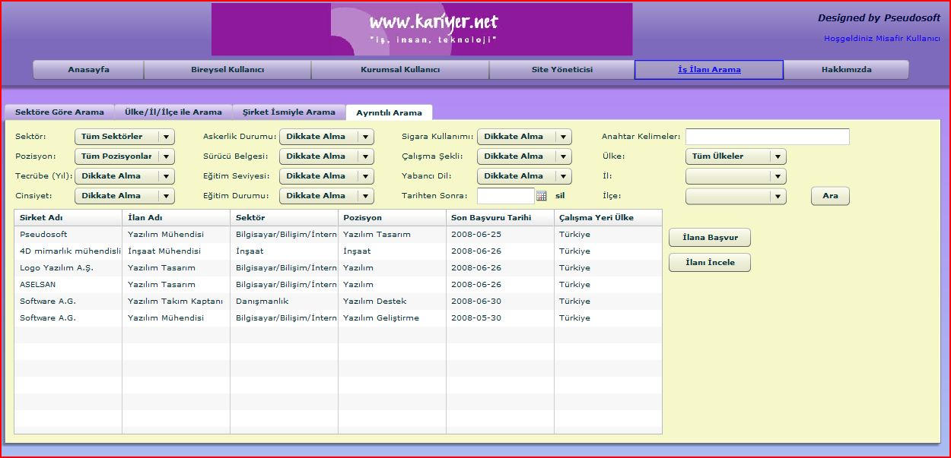

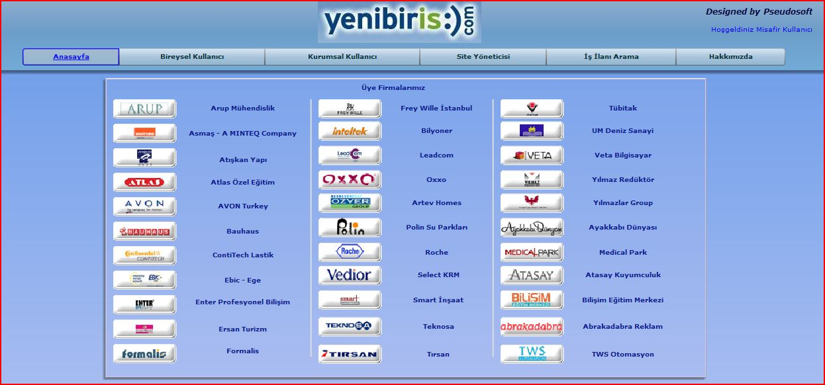

There are 34 Web services we developed, 17 of which is under simulation of kariyer.net and the remaining 17 is under simulation of yenibiris.com.
When you register as a job seeker or a company user to our portal Yenilink, our system uses the Web services provided by the simulated web sites and makes you a user of them automatically. Also as you remove your membership, your memberships of those simulated web sites are also automatically deleted.
When you fill a CV, it will be saved under the database of our portal, but also it will be sent to simulated career web sites. The corresponding CV insertion Web services will take the CV sent, and insert it into their database. And also as you delete or update your CV, the same action will be done by the Web services of simulated career web sites.
If you leave a job announcement as a company user, that announcement will also be sent to simulated career web sites. And also if you delete your announcement, that announcement will also be deleted from those career web sites. However, you are not allowed to update an announcement after you save it. We explained in the previous reports this issue; however, you can see how your announcement looks like at any time before saving it.
If a job seeker user applies to an announcement, that application information is sent to career web sites and held there. When you login as a job seeker, the list of job announcements that you applied with your CVs are taken by using the Web services of the simulated career web sites. Also when a company user enters our system, the list of CVs applied to the announcements of the company is taken from the career web sites using again Web services of them.
Now take attention to this paragraph. When you search job announcements using Yenilink, the search criterions are sent to career web sites using the Web services of them, the search is done by their data access logic and the result is sent to our system by those services. Therefore you can see from which career web site the job announcement is taken in the result table.
There is one final thing about the usage of Web services. When a company user approves a CV that applied to the announcement of the company, the job – cv match information is sent to the simulated career web sites and held there using web services. Our system looks for new matches in every ten seconds using a timer and if there are new matches, the new match information is taken to our Yenilink’s database using Web services of the simulated career web sites. Also, as those services sends the new match information data to our system, they also delete that information from their own databases. Otherwise old match information would be sent in every ten seconds to our system, which will cause wrong statistical graphics to be presented. Therefore the permanent statistical data is being held by our portal’s database. So, when a İskur user gives criterions to see statistical graphics, the search is done in our database.

Below we provide you the layers of our system and how they are related.
JSP Bridge
JSP Bridge
User interface of Kariyer simulation
User interface of Yenibiris simulation
Kariyer simulation Database

Yenibiris simulation Database
Data access logic for Kariyer simulation
Data access logic for Yenibiris simulation
Yenibiris simulation Web services
Kariyer simulation Web services
Yenilink User Interface
JSP Bridge

Data access logic
for Yenilink

Yenilink Database

BANK PAGE
This simulator page is used by companies to pay money to our portal. In fact, the function of this webpage will be satisfied by banking services in a professional environment. But for simulation purposes we needed a banking page. This page provides this. The homepage of banking page is as follows:

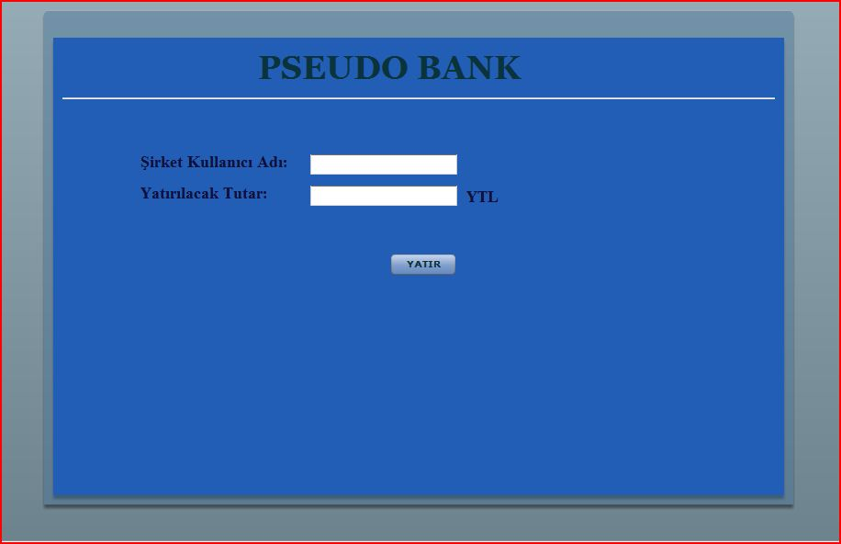

As you can see from the above image, this page is really simple. By entering the company user name and the amount you want to pay, you can deposit money to our portal in order to leave announcements. If the money is successfully added, then you can see this money from your company account by clicking “Üyelik Bilgilerimi Görüntüle” in the registered company user page. Don’t forget that there may be latencies in depositing the money. But most probably you will be able to see the money you have deposited in your next login.

ADMIN PAGE of YENİLİNK
For the system administrator’s purposes, we gave complete access to the databases of the system by this page. In order to use this page, the admin should first login with the admin password. (password is 12345)
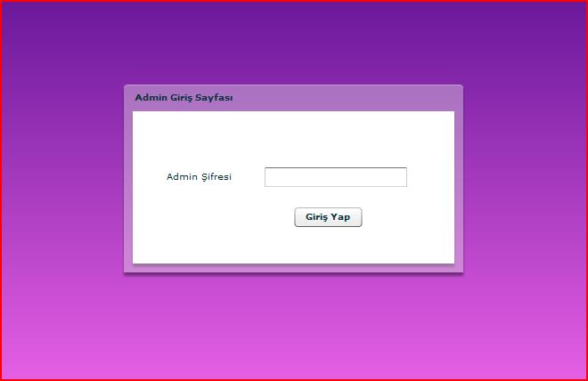
After logging in, you will come across with the following page:
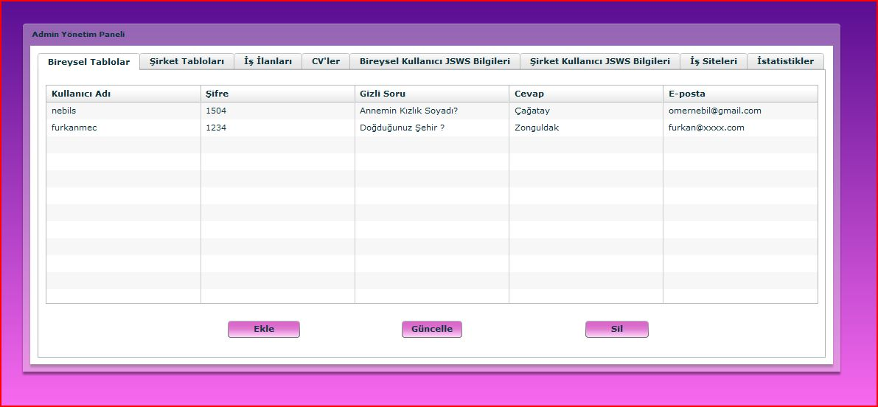
In this page, each tab corresponds to a table in the database. Some of the tables have too many fields to display so that cannot fit into a table. In these type of tables, we have used the “Güncelle” option as “Detay Gör” and we only displayed the most important fields of the table. You can see the details by using “Detay Gör”.
The tables in this page are filled automatically during login and the admin has three functionalities on these pages; “Ekle” meaning add a row to the related database, “Güncelle / Detay Gör” means update a selected row and “Sil” meaning delete the selected row. Here we didn’t put many control mechanisms since this page will be used by authorized people.
In “Ekle” a popup with empty forms corresponding to the columns of the tables comes. The admin fills at least the mandatory fields and approves to be created.
In “Güncelle / Detay Gör” a popup with filled forms corresponding to the data in the selected row will appear and administrator will be free to update any of the data allowed. Don’t forget to select a row before using this functionality else a popup saying “Öncelikle bir satır seçmelisiniz” will appear.
For “Sil”, just select a row and click on it. The row will be deleted from the database.
After all of these operations the related table is updated and the changed information will be reflected to the table shown. We won’t go into more details of this because this was just an overview of our admin page. It will be used by authorized personnel so there is no need to define more details here.

CONTACT INFORMATION
We have tried to cover all issues related for with our portal. We are sure that by the use of simple interface, you will not have any problems while using our portal. But in case of a problem you can always contact us using the following email addresses.

Group E-mail:
pseudosoft@hotmail.com

Group Members Personal E-mails:
Furkan Kürşat Danışmaz k.furkan@gmail.com
Mehmet Bahattin Yaşar bahaddinyasar@gmail.com
Gülsüm Selcen Mülazımoğlu selcen.mulazimoglu@gmail.com
Ömer Nebil Yaveroğlu omernebil@gmail.com

Thanks for your interest on our portal…

