METU CENG491 2015 FALL

START-UP DOCUMENT

<UID>
Group Name: | <Cow-BoyZ>
Project Name: | <GUBHT>

1. System Architecture
- Draw the overall system architecture diagram. This should include (but it is not limited to) the components of the system, the interactions among the components and their dependencies.
- Identify and describe each component (including subcomponents if any), their interactions and dependencies clearly.
- Specify the user interaction model.

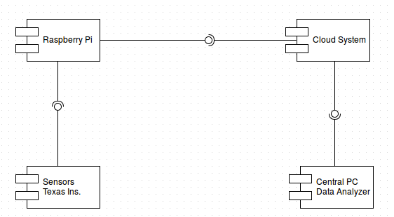
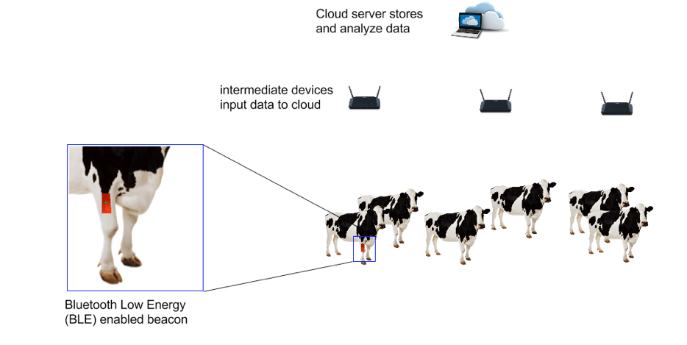
2. Tentative Time Plan
- Identify and itemize all tasks to be performed as a team in the first semester. Assign a unique TaskID for each task. Give a short name and brief description for each identified task.

TaskID | Short Name | Description
T1 | Examine | Gather general information about aspects of the projects.
T2 | Technical Details | Trying to understand technical details of the project. Sensors, devices, systems etc.
T3 | Signal Research | Research on signal process and analyze.
T4 | Data Collection | Collecting data from sensors and devices to a linux based system.
T5 | Research Cloud | Trying to determine which cloud sysyem is appropriate.
T6 | Raspberry Pi analyze | Trying to learn basic aspects of raspberry pi and arrange it's connections.
T7 | Gathering Sample from People | Gathering samples to analyze behavior of people
T8 | Gathering Sample From Animals | Gathering large amount of samples from animals to learn behaviors of them
T9 | Cloud Interaction | Connecting system to cloud
T10 | Data Analyze | Downloading and processing data
T11 | Field Work | Going to animal farm
T12 | Meeting with Veterinarian | Meeting with veterinarian

- Construct your time plan as a simplified Gantt chart, as shown in the following table.

 | Iteration1 | Iteration2 | Iteration3
T1 | 
T2 | X
T3 | X | X | X
T4 | X | X | X
T5 | X
T6 | X
T7 | X | X
T8 |  | X | X
T9 | X | X
T10 |  | X | X
T11 | X | X | X
T12 | X

3. Deliverables
- Identify and list all deliverables of your project for the first 3 sprints.
- A deliverable is some component or sub-component, which is running and demonstrable to your assistant and your supervisor. That deliverable is of course subject to improvement over time.
- Fill in the following table:

Deliverable | Description | When? (Sprint#)
D1 | Sample cattle movement
D2 | Raspberry Pi connection
D3 | Cloud Connection
D4 | Process Data

4. Workload Distribution
Fill in the following table to distribute the workload for the first semester among your team members.

 | Sprint - I | Sprint - II | Sprint - III
<Ali Şahbaz> | T1, T2, T3 | T7, T8, T11, D1, T12 | T8, T11, T12, D1
<Emre Durdağı> | T1, T2, T4, T5 | T9, T10, T11, T12 | T9, D3, T12, D4
<Ömer Toker> | T1, T2, T3, T5, T4 | T7, T8, T10, T11, D1, T12 | T7, T8, T10, T12, D1
<Ekincan Yalçın> | T1, T2, T3 | T6, T11, T9, D3, T12, D2, T7 | T6, T12, D3, D2, T8

