**CEng 491 -- Project KickOff Document**

**“AgroIntelligence” KickOff Document**

**Description**

This project will especially be developed for the “Sunn pest” which is a wheat pest. This insect spends its life time in two different areas that are called “kışlak” and wheat field. It migrates to field from “kışlak”. After migration, the wheat field should be sprayed at a certain growing phase of the insect. The Ministry of Agriculture has devices (weather stations produced by METOS) in both “kışlak” and wheat field. These devices have already deployed and functional in 800 locations giving exhaustive information about physical conditions such as temperature and humidity. The project will decide the spraying date by applying machine learning algorithms on this data. This project can be used by Republic of Turkey Ministry of Food, Agriculture as a package module to the devices in the fields. Furthermore, farmers and agricultural engineers can use the website that includes forecasting and warning system to check the spraying date and detailed information about current phase of the Sunn Pest in its ecological life-cycle.

**Master feature list**

* **MF 1**

Data collection software that pulls data from the web services run by METOS weather stations.

* **MF 2**

A flexible database application to store collected data with searching capabilities on the raw and processed data according to various criteria

* **MF 3**

A web based server application that triggers daily data collection, daily predictions and logging

* **MF 4**

Prediction models that estimate phase of the sunn pest in its ecological life cycle.

* **MF5**

Prediction models that estimate pesticide application time on fields.

* **MF 6**

Parameter and hyper-parameter optimization applications in order to improve current prediction results on a large set of small datasets with lots of attributes (more than 60) but limited instances (about 2500) by using machine learning and deep learning algorithms.

* **MF 7**

A website that displays spraying dates and ecological life-cycle of sunn pest.

Also, presenting the results on a geographical information system based on Google Maps API.

* **MF8**

SMS warning module

* **MF9**

Client Panel for agricultural engineers and farmers

* **MF10**

Admin panel

**Workpackages**

|  |  |  |  |
| --- | --- | --- | --- |
| **WP #** | **Term** | **WP title (this should be as short and as descriptive as possible)** | **Estimated number of man-months** |
| 1 | 491 | Project planning, architecture design | 3 |
| 2 | 491 | Database design, Data collection, preprocessing, trigger software | 5 |
| 3 | 491 | Library Survey: Weka, Tensorflow and one other library | 3 |
| 4 | 491 | Model Development – 1 (Phase) | 3 |
| 5 | 491 | Server setup, Prototype Admin Panel, Prototype Client Panel | 3 |
| 6 | 492 | Model Development – 2 (Pesticide application time) | 3 |
| 7 | 492 | Admin Panel, Client Panel | 3 |
| 8 | 492 | Warning Module, SMS Module | 2 |
| 9 | 492 | Integration Testing, User Acceptance Testing, Going Live | 3 |
| 10 | 492 | Wrapping up and Client Presentations | 2 |
| 11 | Bonus | Adapting the project to “kımıl” pest | - |
| 12 | Bonus | Publishing an article | - |

**Detailed Descriptions of High-Level Workpackages**

**WP1 - Project planning and architecture design**

In this workpackage, the following functionalities / features / work items will be implemented

1. Develop the list of master features of the project.
2. Produce project development plan in accordance with Master Feature List.
3. Design the overall architecture of the project.
4. Analyze risks and make a management plan.

**WP2 - Database design,** **data collection, preprocessing, trigger software**

In this work package, the following functionalities / features / work items will be implemented

1. Designing the database on the conceptual level.
2. Implementation of SQL code to create schemas.
3. Developing a data collection software that collects data via Metos web services.
4. Preprocessing of raw data (Estimating or eliminating missing values, dimensionality reduction etc.)
5. Developing a trigger software that runs the data collection software at a certain period.

**WP3 - Library Survey: Weka, Tensorflow and one other library**

In this workpackage, the following functionalities / features / work items will be implemented

1. Learning the usage of Weka tool, working on collected data.
2. Learning the usage of Tensorflow, working on collected data.
3. Searching for another library to apply ML algorithms on the data.
4. Deciding the most suitable tool for our project

**WP4 - Model Development – 1 (Phase)**

In this workpackage, the following functionalities / features / work items will be implemented

1. Construction of decision trees in prediction models (linear prediction approach).
2. Building neural network models (non-linear prediction approach)
3. Running, testing and tuning the models developed
4. Deciding the most efficient models that will be used
5. Possible (optional) research on boosting

**WP5 - Server setup, Prototype Admin Panel, Prototype Client Panel**

In this workpackage, the following functionalities / features / work items will be implemented

1. Creating a VM on the cloud, using it as a web server.
2. Deciding the necessary applications for development and environment setup
3. Developing a prototype of admin panel (for agricultural and computer engineers)
4. Developing a prototype of client panel (for the farmers)

**WP6 - Model Development – 2 (Pesticide application time)**

In this workpackage, the following functionalities / features / work items will be implemented

1. Construction of decision trees in prediction models.
2. Building neural network models
3. Running and testing the models developed
4. Deciding the most efficient models that will be used
5. Possible (optional) research on boosting
6. Possible (optional) research on deep learning approaches

**WP7 - Admin Panel, Client Panel**

In this workpackage, the following functionalities / features / work items will be implemented

1. Detecting and fixing the shortcomings of prototype panels.
2. Inserting the new qualifications that comes after the development of “Pesticide Application Time” prediction models.
3. Adaption of trending web design technologies. (CSS, Bootstrap, …)

**WP8 - Warning Module, SMS Module**

In this workpackage, the following functionalities / features / work items will be implemented

1. Developing a software to warn farmers slightly before the pesticide application time.
2. Delivering the warning message via different environments (website, mailing, SMS).
3. SMS module implementation.

**WP9 - Integration Testing, User Acceptance Testing, Going Live**

In this workpackage, the following functionalities / features / work items will be implemented

1. Testing all the software modules after integration as a whole
2. Testing according to user’s preferences
3. Live testing of the project on the field, confirmation of the farmers based on the count of Sunn Pest

**WP10 - Wrapping up and Client Presentations**

In this workpackage, the following functionalities / features / work items will be implemented

1. Minor arrangements on documents.
2. Minor changes on the software according to the feedbacks of customers after testing.
3. Presentation of the project to the Ministry of Agriculture

**WP11 – Bonus - Adapting the project to “kımıl” pest**

In this workpackage, the following functionalities / features / work items will be implemented

1. Modifying the prediction models so that they can be used on “Kımıl” pest.
2. Rearrangment of client side according to additional features
3. Verifying the results with agricultural engineers.

**WP12 – Bonus - Publishing an article**

In this workpackage, the following functionalities / features / work items will be implemented

1. Publishing a paper on “Application of Artificial Intelligence on Agriculture”.
2. Sending the paper to USMOS/SAVTEK, TARGID

**Overall Systems Architecture**

The Data Collecting software pulls the data from the weather stations by using the API that METOS provides. Then, it inserts the data to database. Prediction methods run according to the data inserted in database. These two software parts are triggered by a Daily Periodic Triggering Software. A web server is available for displaying the results of the prediction models. A client panel will be developed that shows phases of the Sunn Pest in its ecological life cycle and predicted pesticide application dates to end users. An admin panel that has a permission to view tables will also be developed. Furthermore, an SMS Alert Software notifies the end users according to the data accessed from database.

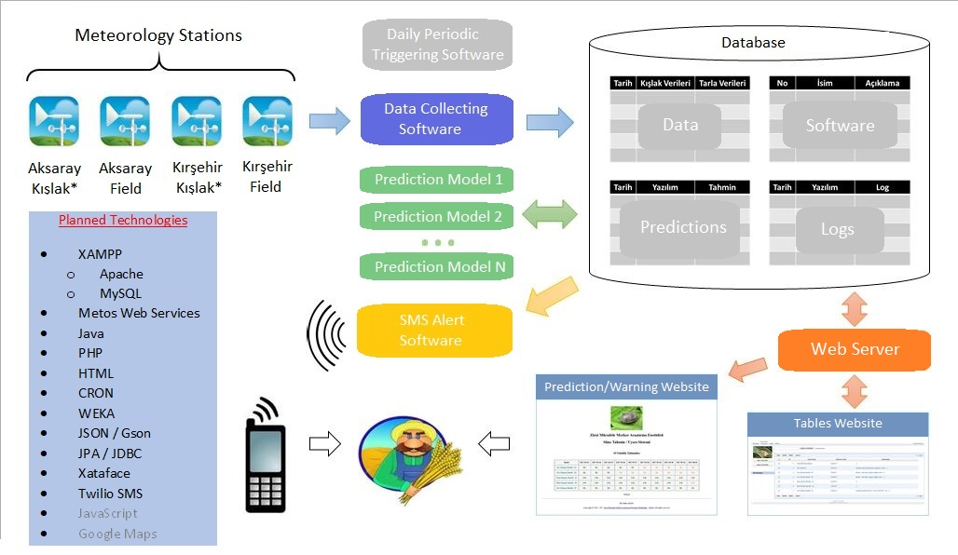

*kışlak: This insect spends its life time in two different areas that are called “kışlak” and wheat field. This is the place that Sunn Pest stays during winter.

**TimeLine**

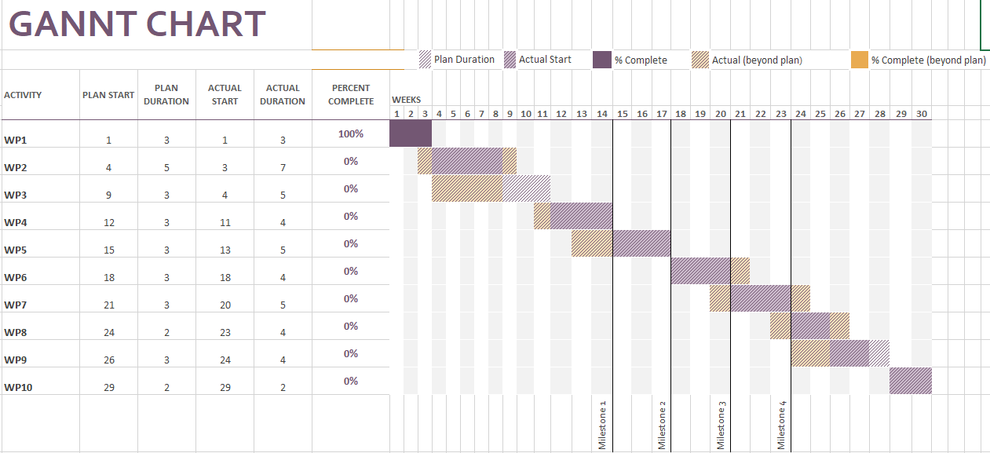

Milestone 1: At the end of week 14 Model Development for Phase should be completed.

Milestone 2: At the end of week 17 Prototypes of Admin and Client Panel should be presented on the server.

Milestone 3: At the end of week 20 Model Developments for Phase and Pesticide Application Time should be completed.

Milestone 4: At the end of week 23 Admin and Client Panel should be completed.

**Risk Assessment**

|  |  |  |
| --- | --- | --- |
| **Risk #** | **Description** | **Possible Solution(s)** |
| 1 | Dealing with possible overfit due to size of data | Class balancing |