Ceng 491 -- Group 15 Project KickOff Document

AlgoTrading Kickoff Document

Description

This project aims to provide a general framework in order to create a pipeline for creating, testing and optimizing trading algorithms. The application will be web-based for being easily accessible, user-friendly, and easy to start for the users. Three main components can be further defined as follows:
a) Algorithm Creation Interface: This supports composing an algorithm from different indicators, using graphical user interface bindings.
b) Back Testing Client: This allows users to test their algorithms against previous real-world data, fetched from various sources.
c) Optimization & Feedback: The parameters used inside the indicator are optimized using various machine learning techniques to give the user feedback about his/her system.

Master Feature List

- Login and account creation features, user authorization
- Ability to save and reload created algorithms
- Ability to upload custom data
- Drag and drop for ease of use of indicators and their relationships
- Interactive graph visualization
- Cross-comparison features among algorithms and other investment options
- Live algorithm and its visualization
- Real time updates of databases, algorithms and visualizations
- Ability to watch selected stock prices in real time
- Ability to backtest algorithm against given or custom data
- Ability to add and modify a variety of built-in indicators
- Ability to create custom indicators
- Optimizations of algorithm parameters with machine learning

Workpackages

WP # | Term | WP title | Estimated number of man-months
1 | 491 | Project planning, library research and architecture design | 2
2 | 491 | Frontend initialization | 2
3 | 491 | Backend initialization | 2
4 | 491 | Production ready frontend development | 3
5 | 491 | Production ready backend development | 3
6 | 491 | Integration and testing of the frontend and backend | 3
7 | 492 | Development of the algorithmic trading backend | 4
8 | 492 | Optimization features and machine learning research | 5
9 | 492 | Integration and user testing | 3
10 | 492 | Wrap-up | 3
 |  | Total: | 30
i | opt (491) | Android Mobile Application
ii | opt (492) | Predicting future market and profits
iii | opt (492) | Trading with real money
iv | opt (492) | Quality of life

Detailed Descriptions of High-Level Workpackages

WP1 - Project planning, library research and architecture design
- Develop the list of master features of the project.
- Produce project development plan in accordance with Master Feature List.
- Design the overall architecture of the project.
- Analyze risks and make a management plan.
- Make research about libraries

WP2 - Frontend initialization
- Decide which resources to use
- Design of the scenes and state logic according to multiple use cases
- Start to develop frontend

WP3 - Backend initialization
- Deciding on which resources to use
- Design of the database
- Creating API for frontend communication

WP4 - Production ready frontend development
- Development of the drag and drop for indicators (and their relationships)
- Development of the graph visualization (line, candlestick etc.) for data
- Development of the cross-comparison with other options and its visualization

WP5 - Production ready backend development
- Migration of the system to a suitable remote machine
- Add authentication for users
- Ability to add custom data

WP6 - Integration and testing of the frontend and backend
- Establishing real time updates of databases, stock prices and visualizations
- Establishing the communication between frontend and backend
- Replacing the dummy data with respective real world data

WP7 - Development of the algorithmic trading backend
- Implementing the backtesting algorithm
- Implementing indicators and their integration to both frontend and backend
- Developing custom indicator creation interfaces
- Implementing the live algorithm and its visualization

WP8 - Optimization features and machine learning research
- Finding appropriate machine learning techniques and utilizing them for parameter optimization in algorithms

WP9 - Integration and user testing
- Making final integration tests to ensure overall compatibility of the components
- Making user tests to ensure the usability of the system

WP10 - Wrap-up
- Bug fixes, final corrections, concluding the project

OPT1 - Quality of life
- Color coding indicators and their relations
- Social media integration
- Tutorial for teaching the usage of the system
- Different front-end styles, e.g. night mode
- Further improvements for a user friendly interface

OPT2 - Predicting future market and profits
- Predicting future stock market prices with machine learning and giving feedback

OPT3 - Trading with real money
- Establishing connection to real market servers to allow trading with real life money

OPT4 - Android Mobile Application
- Clone of the web application
- Make necessary changes for native platform

Overall Systems Architecture

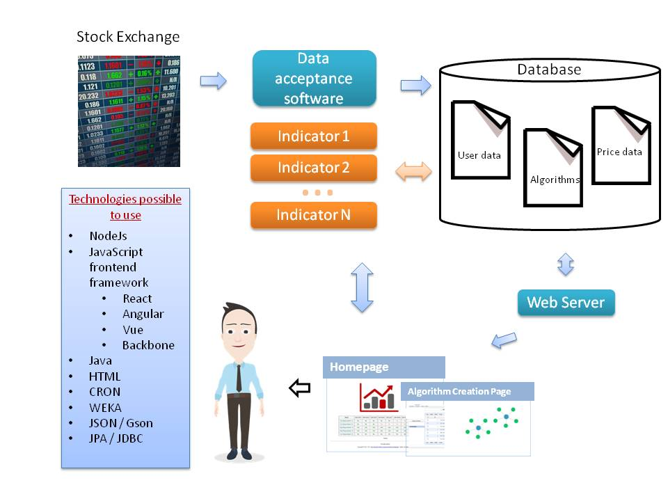

TimeLine

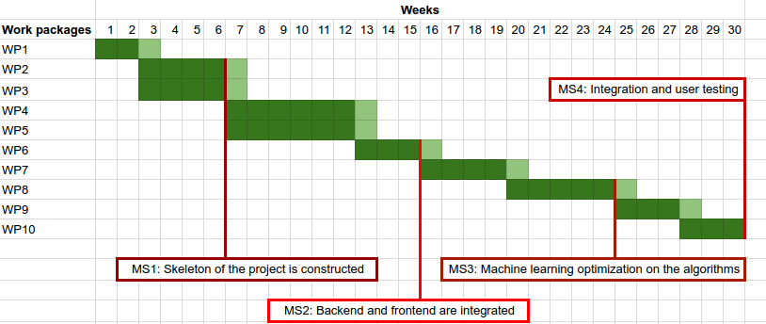

Risk Assessment

Risk # | Description | Possible Solution(s)
1 | Risks associated with machine learning processes, such as overfitting | Further research, more data, change in ML strategies

