**CEng 491 -- Project KickOff Document Template**

This document describes the content of the KickOff Document that the project groups are supposed to iterate and finalize with their Assistant, Supervisor and Coordinators.

**Donut_English KickOff Document**

Onur Demirtaş, 1941939

Şükran Okul, 1679117

MOHAMMED L. N. ALQOTTOB , 2001485

**Description**

Donut_English is a software that guides majority of Turkish speakers of English including METU students to improve their vocabulary & grammar skills, it also provides error reduction. It will be used as a mobile application using speech recognition technology..

**Master feature list**

MF-1: Speech recognition Postprocessing

MF-2: Vocabulary development using Natural Language Processing Techniques

MF-3: Error Reduction using Natural Language Processing Techniques

MF-4: GUI based annotation visualization

MF-5: Saving annotated English vocabularies in NoSQL database system

MF-6: Simple GUI for iOS app

MF-7: Simple GUI for Android app

MF-8: Machine Learning of Common Mistakes

MF-9: Part of Speech Tagging

MF-10: Studying available data

**Workpackages**

|  |  |  |  |
| --- | --- | --- | --- |
| **WP #** | **Term** | **WP title (this should be as short and as descriptive as possible)** | **Estimated number of man-months** |
| 1 | 491 | Project planning and architecture design | 1 |
| 2 | 491 | Literature Research | 3 |
| 3 | 491 | *Implementing NLP algorithms and employing libraries Part1* | 6 |
| 4 | 492 | *Implementing NLP algorithms and employing libraries Part2* | 2 |
| 5 | 492 | *Annotation visualization* | 2 |
| 6 | 492 | Saving the annotated words in database | 2 |
| 7 | 492 | Creating the Android app | 2 |
| 8 | 492 | Creating the iOS app | 3 |
| 9 | 492 | Testing the mobile apps and NLP software | 1.5 |
|  |  | Total: | 3*7.5 = 22.5 |

**Detailed Descriptions of High-Level Workpackages**

**WP1 - (Project planning and architecture design)**

In this workpackage, the following functionalities / features / work items will be implemented:

1. Develop the list of master features of the project.
2. Produce project development plan in accordance with Master Feature List.
3. Design the overall architecture of the project.
4. Analyze risks and make a management plan.

**WP2 - (Literature Survey)**

1. Learning NLP libraries (SpaCy, NLTK)
2. Learning the basics of Natural Language Processing

**WP3 - (*Implementing NLP algorithms and libraries- Part1*)**

1. Creating the NLP algorithms
2. Deciding the related libraries(SpaCy, NLTK)

**WP4 - (*Implementing NLP algorithms and libraries- Part2*)**

1. Implementing the created NLP algorithms
2. Importing the related libraries(SpaCy, NLTK)

**WP5 - (Annotation visualization)**

1. Using Mmax2 software tool for text annotation visualization

**WP6 - (Saving the annotated words in database)**

1. Creating the backend server application with NodeJS, ExpressJS
2. Creating MongoDB database schema
3. Saving the related data to the database

**WP7 - (Creating the Android app)**

1. Creating the simple UI of the app
2. Implementing Google Speech Recognition API
3. Postprocessing Siri output
4. Connecting the web services with the app

**WP8 - (Creating the iOS app)**

1. Creating the simple UI of the app
2. Using Siri for speech recognition
3. Connecting the web services with the app

**WP9 - (Testing the mobile apps and NLP software)**

1. Testing the mobile apps
2. Testing the NPL software & algorithms

**Overall Systems Architecture**

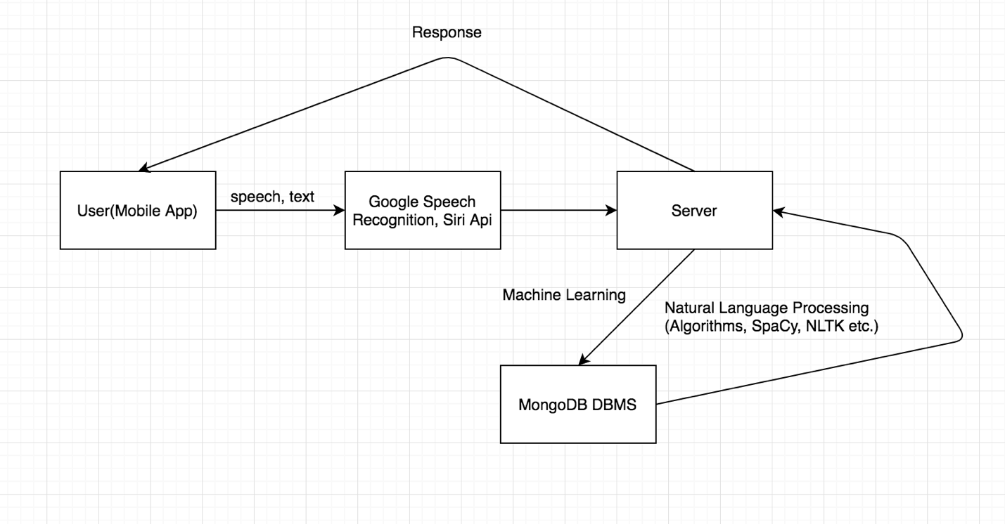

**TimeLine**

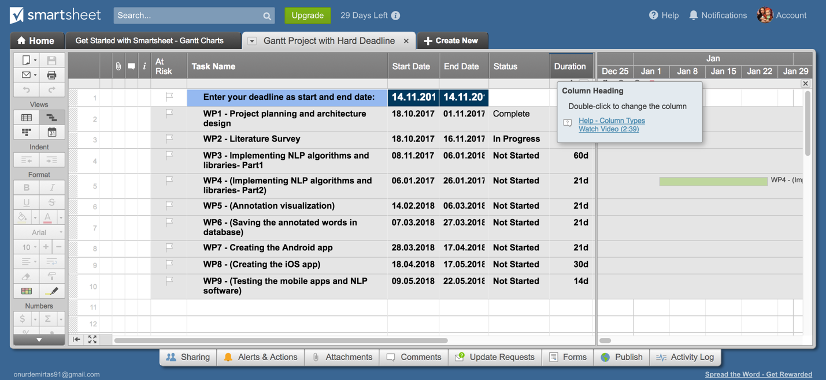

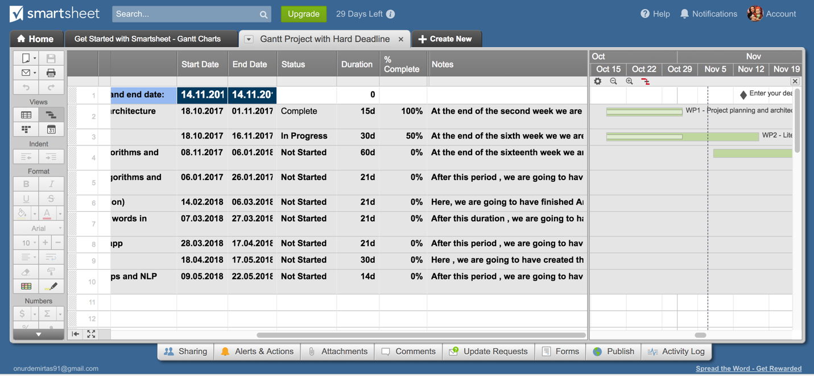

The full chart is at this link:

<https://app.smartsheet.com/b/publish?EQBCT=9e307d9954d34d7bb872748aea6af99c>

**Risk Assessment**

In this section of the kick-off document, list (and briefly discuss) all foreseen risk items that (when realized) will be a major obstacle for successful completion of the project.

|  |  |  |
| --- | --- | --- |
| **Risk #** | **Description** | **Possible Solution(s)** |
| 1 | Low performance of error reduction algorithms used | Using better algorithms and solutions for NLP |
| 2 | Performance of server-side may be slow | Increasing the performance by optimizing the code |