**CENG 491**

**MobileSR KickOff Document**

**Description**

MobileSR aims to bring deep-learning based single image super-resolution to mobile phones. The end-product will be an Android application that can apply super-resolution to both images stored in the phone gallery, and photographs taken by the camera through the application. The application will be able to process either a single image or multiple images in the background and will be able to save or share the enhanced images, as well as show the improvement in image quality.

The most important part of the project is being able to construct an on-device program that will attain reasonable performance on mobile camera images, which are already high-resolution, without encountering out-of-memory issues. Recently developed frameworks such as TensorFlow Lite and techniques such as model compression/quantization will be leveraged for this purpose.

**Master feature list**

MF-1: Increasing the resolution of a single provided image by a factor of two

MF-2: Gallery browsing functionality for selecting the image

MF-3: The ability to select only a part of the image to be enhanced by pinch zooming

MF-4: Ability to enhance the currently viewed part of the image by pressing a button

MF-5: Ability to overwrite the original image with the enhanced image (if the full image has been enhanced) or save it with a different name

MF-6: Ability to share enhanced image using Android’s sharing interface

MF-7: Ability to select multiple images from the gallery to be processed

MF-8: Ability to process the multiple selected images in the background

MF-9: Ability to follow the current progress from the notification bar for multiple selections

MF-10: A tutorial demonstrating the usage of the application to new users

MF-11: Ability to switch between the outputs of linear interpolation and application’s super resolution model via a toggle button for instantaneous comparison

**Workpackages**

|  |  |  |  |
| --- | --- | --- | --- |
| **WP #** | **Term** | **WP title (this should be as short and as descriptive as possible)** | **Estimated number of man-months** |
| 0 |  | Pre-Work : Kickoff preparation and environment setup | 1 |
| 1 |  | Investigation of state-of-art super resolution technique applicable to mobile system software/hardware | 3 |
| 2 |  | Deep learning model development and training | 5 |
| 3 |  | Investigation of deep learning model compression technique | 3 |
| 4 |  | Mobile application core functionality design and implementation | 7 |
| 5 |  | Mobile application side functionality design and implementation | 6 |
| 6 |  | Integration of the model to the Mobile App | 3 |
| 7 |  | Decision of minimum system requirements and release of the product | 1 |
| 8 |  | Preparation of the website of the Project | 1 |
| 9 |  | (Bonus)Server side processing | - |
| 10 |  | (Bonus)Different models for different categories | - |
|  |  | Total: | 30 |

**Detailed Descriptions of High-Level Workpackages**

**WP0 -** Pre-Work : Kickoff preparation and environment Setup

1. Preparation of the kickoff document.
2. Development environment setup

**WP1 -** Investigation of state-of-art super resolution techniques applicable to mobile systems

1. Familiarization with the selected deep-learning ecosystem on both mobile and computer platforms
2. Literature research on neural network models for single image super resolution that is applicable to mobile
3. Testing convenient untrained neural network models on an Android demo app for platform familiarization
4. Deciding on timing requirements and the initial model to be used

**WP2 -** Deep Learning Model Development and Training

1. Preparation of different learning datasets of the selected neural network model for single image super resolution
   1. **(Bonus feature)**: Prepared datasets may cover different categories of images, e.g. Portraits, Nature, Low exposure photos to increase the enhancement quality.
2. Preparation of a framework to evaluate trained model performance before deployment for comparison
3. Training various models by using different architectures and dataset compositions, while making sure all models are compatible with the mobile platform
4. Measurement of performance of the trained models both time-wise and accuracy-wise, and selecting the best model for deployment

**WP3 -** Investigation of deep learning model compression techniques

1. Investigation and testing of deep learning model compression techniques applicable to Android platforms
2. Performance measurements and selection of a model compression technique

**WP4 -** Mobile application core functionality design and implementation

1. Getting familiar with development for the Android platform
2. Creating a demo UI for the testing of features of WP4
3. Design and Implementation of gallery browsing component of the app
   1. Implementation of the single image selection functionality
4. UI for zooming or selecting the part of the image that is to be processed
5. Design and Implementation of the application pipeline
6. Preprocessing of the image
   1. Design and Implementation of an algorithm to divide the image into grids for parallel and uniform processing
   2. Preparation of the image for feeding into the integrated model
7. UI for showing the result

**WP5 -** Mobile Application Side Functionality Design and Implementation

1. Creating the main application UI for users to interact with the app
2. Improvement of gallery browsing component of the app in terms of functionality
   1. Implementation of the multiple image selection functionality
3. Design and Implementation of the UI for showing the enhanced image
   1. The user will be able to preview and zoom on the image, and compare the result with the original image as well as basic interpolation technique results
   2. The user will be able to save the image using different saving settings such as saving only the cropped version, ability to overwrite the processed image etc.
   3. User will be able to share the image via different platforms such as email, instant messaging etc.
4. Design and Implementation of the Tutorial UI
5. Implementation of settings screen UI
6. Implementing the ability to instantly capture a photo to be enhanced

**WP6 -** Integration of the Model to the Mobile App

1. Investigation of the current available libraries and frameworks that supports our neural network framework on Android System
2. Determining the viability of using dedicated hardware (GPU) on the mobile platform and integrating changes required to make use of the dedicated hardware
3. Conversion and implementation of the integration process

**WP7 -** Decision of minimum system requirements and Release of the product

1. Testing use cases on different phones to determine the minimum system requirements of the application
2. Creation of a google play store account and release of the application

**WP8 -** Preparation of the website of the project

1. Prepare a website and material for introducing and presenting the project

**Overall Systems Architecture**

Our project will be a standalone application running on an Android powered mobile phone. All the functionality will be provided by a single application. The model that will be enhancing the selected image(s) will be pre-trained and deployed along with the application.

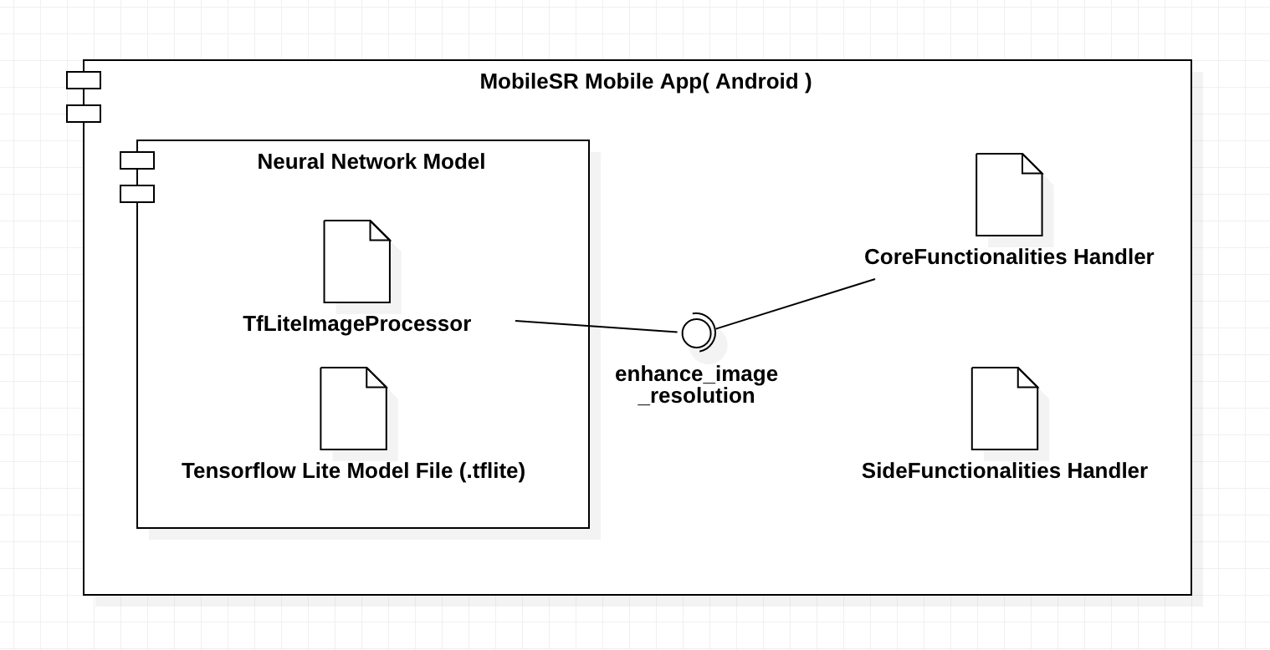

*Figure 1 : Overall System Architecture Diagram of the app showing the component interactions of the app.*

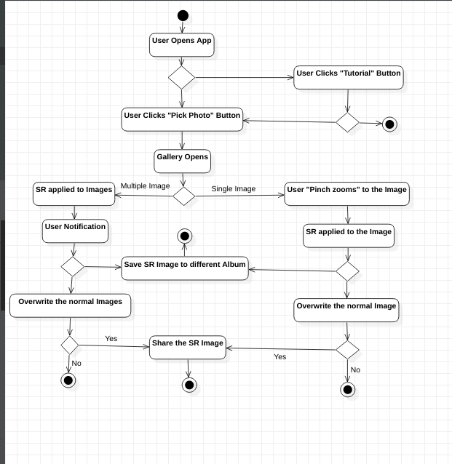

*Figure 2 : Activity Diagram of the user interaction to the app.*

**TimeLine of the Project**

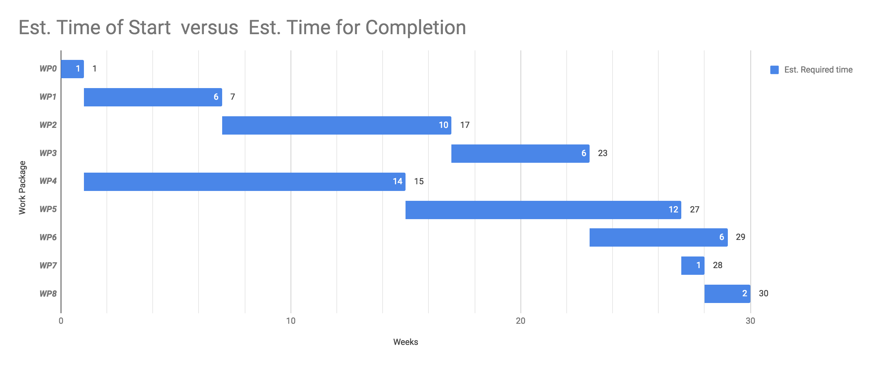

*Figure 3 : Timeline Chart*

**Risk Assessment**

|  |  |  |
| --- | --- | --- |
| **Risk #** | **Description** | **Possible Solution(s)** |
| 1 | Performance may not meet the requirements | Use model compression, parallel processing, lighten the superresolution model considering both time and memory constraints |
| 2 | Unexpected bugs or backward incompatible changes in 3rd party libraries | Employ a test driven approach for development |
| 3 | Lack of documentation on using GPU or dedicated hardware for running models on the Android platform | Prototyping possible solutions before selecting the one that is to be used in end product |
| 4 | Lack of performance due to limitations of the mobile devices’ hardware/software limitations | Use a back-end system instead, to delegate the super resolution model calculations in a powerful machine |